Web Technologies Lab Manual as per JNTUK-R13

1. Design the following static web pages required for an online book store web site.
- HOME PAGE:

The static home page must contain three frames.

Top frame: Logo and the college name and links to Home page, Login page, Registration page, Catalogue page and Cart page (the description of these pages will be given below).
Left frame: At least four links for navigation, which will display the catalogue of respective links.

For e.g.: When you click the link “MCA” the catalogue for MCA Books should be displayed in the Right frame.

Right frame: The pages to the links in the left frame must be loaded here. Initially this page contains description of the web site.

head.html

<html>
<head>
<title>Head Page</title>

</head>
<body>
<font face="Arial Black" size="3">

<table border="1" cellspacing="2" cellpadding="5" width="100%"> <tr>

<td align="center"><img src="6.jpg" width="20" height="20"/></td> <td colspan="4" align="center">Web Site Name</td>

</tr>

<tr>

<td align="center"><a href="description.html" target="des_page">HOME</a></td> <td align="center"><a href="login.html" target="des_page">LOGIN</a></td>

<td align="center"><a href="registration.html" target="des_page">REGISTRATION</a></td> <td align="center"><a href="catalogue.html" target="des_page">CATALOGUE</a></td> <td align="center"><a href="cart.html" target="des_page">CART</a></td>
</tr>
</table>

</font>
</body>
</html>

OUTPUT:
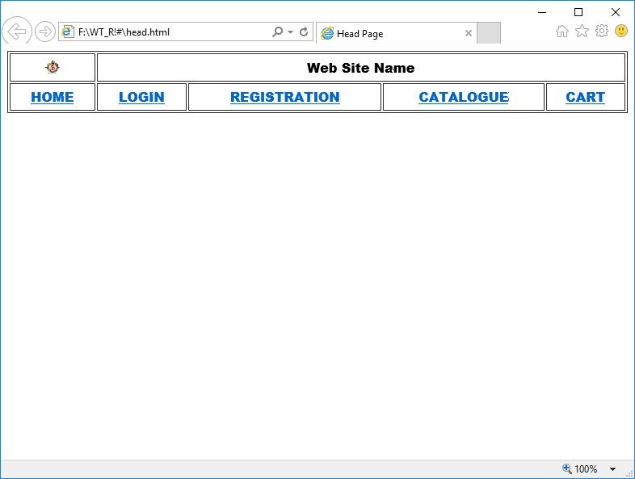

Ch. Vijayananda Ratnam@Dept. Of Computer Science | 1

Web Technologies Lab Manual as per JNTUK-R13

dept.html

<html>
<head>
<title>Departments Page</title>

</head>
<body>
<font face="Arial Black" size="4">
<table align="center" height="100%">

<tr>
<td><a href="cat_mca.html" target="des_page">MCA</a></td>
</tr>
<tr>

<td><a href="cat_mba.html" target="des_page">MBA</a></td>
</tr>
<tr>
<td><a href="cat_bca.html" target="des_page">BCA</a></td>

</tr>
</table>
</font>
</body>

</html>

OUTPUT:
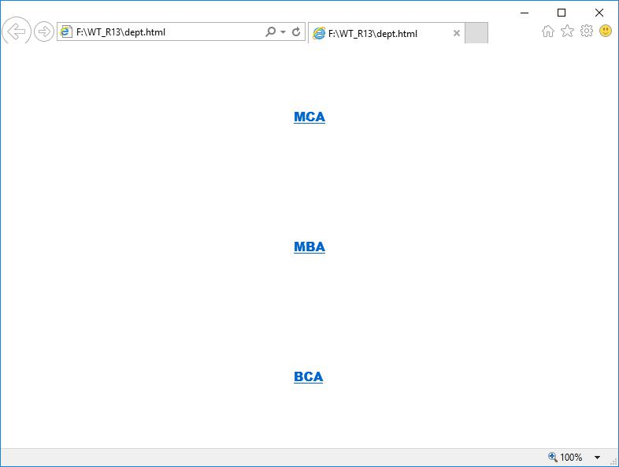

Ch. Vijayananda Ratnam@Dept. Of Computer Science | 2

Web Technologies Lab Manual as per JNTUK-R13

desc.html

<html>
<head>
<title> Description page</title>

</head>
<body>
<br><br><br><br><br><br><br><br><br><br>
<font face="TIMES NEW ROMAN" size="5">

<center>
Description of the Website
</center>
</font>

</body>
</html>

OUTPUT:
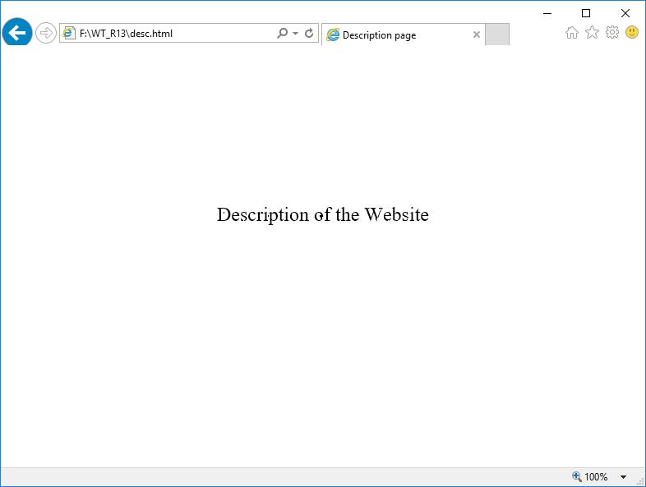

Ch. Vijayananda Ratnam@Dept. Of Computer Science | 3

Web Technologies Lab Manual as per JNTUK-R13

home.html

<html>
<head>
<title>Home page</title>

</head>
<frameset rows="20,80">
<frame src="head.html" name="head_page">
<frameset cols="15,85">

<frame src="dept.html" name="dept_page">
<frame src="desc.html" name="des_page">
</frameset>
</frameset>

</html>

OUTPUT
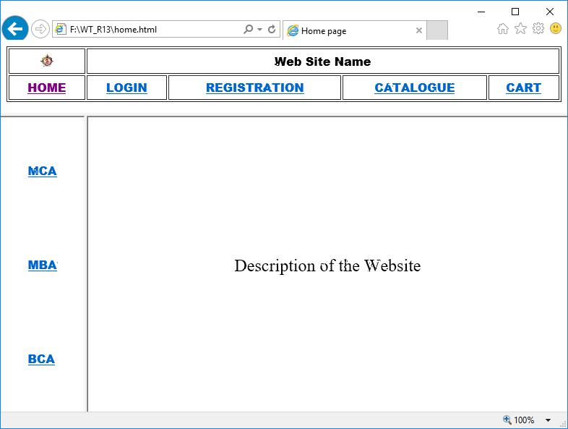

Ch. Vijayananda Ratnam@Dept. Of Computer Science | 4

Web Technologies Lab Manual as per JNTUK-R13

- LOGIN PAGE: Login page must contain Login field, Password field, Submit and reset buttons. login.html

<html>

<head>
<title>Login page</title>
</head>
<body>

<center>

<font face="Arial Black" size="4"><u><b>LOGIN FORM</b></u></font> <br><br>

<form name="f1" action="" method="post">

<table frame="box" cellspacing="10">
<tr>
<td>Login</td>
<td><input type="text" size="25"></td>

</tr>
<tr>
<td>Password</td>
<td><input type="password" size="25"></td>

</tr>
<tr>
<td colspan="2" align="center"><input type="submit" value="SUBMIT">
&nbsp;&nbsp;&nbsp;&nbsp;&nbsp;

<input type="reset" value="RESET"></td>
</tr>
</table>
</form>

</center>
</body>
</html>

OUTPUT
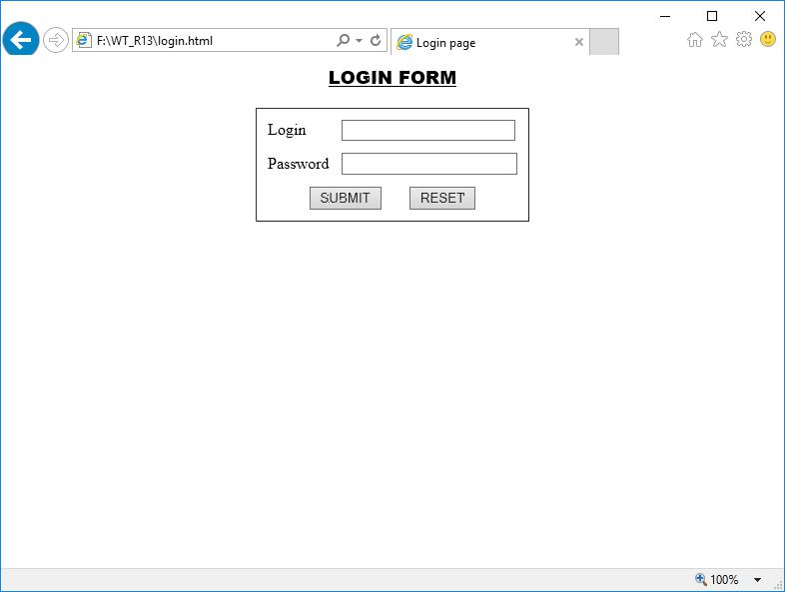

Ch. Vijayananda Ratnam@Dept. Of Computer Science | 5

Web Technologies Lab Manual as per JNTUK-R13

3. CATALOGUE PAGE:

The catalogue page should contain the details of all the books available in the web site in a table. The details should contain the following:

- Snap shot of Cover Page.
- Author Name.

- Publisher.
- Price.
- Add to cart button.

catalogue.html

<html>
<head>

<title> Catalogue Page</title>
</head>
<body>
<table width="100%" height="100%" border="1">

<tr>
<td><img src="xmlb.gif" height="100" width="100"/></td>
<td>Book: XML Bible
<br>Author: Winston

<br>Publication: Wiely</td>
<td>$40.5</td>
<td><img src="adc.gif" height="100" width="100"/></td>
</tr>

<tr>
<td><img src="ai.gif" height="100" width="100"/></td>
<td>Book: AI
<br>Author: S.Russel

<br>Publication: Princeton hall</td>
<td>$63</td>
<td><img src="adc.gif" height="100" width="100"/></td>
</tr>

<tr>
<td><img src="java2.gif" height="100" width="100"/></td>
<td>Book: Java 2
<br>Author: Watston
<br>Publication: BPB publications</td>

<td>$35.5</td>
<td><img src="adc.gif" height="100" width="100"/></td>
</tr>
<tr>

<td><img src="html.gif" height="100" width="100"/></td>
<td>Book: HTML in 24 hours
<br>Author: Sam Peter
<br>Publication: Sam publications</td>

<td>$100</td>
<td><img src="adc.gif" height="100" width="100"/></td>
</tr>
</table>

</body>
</html>

Ch. Vijayananda Ratnam@Dept. Of Computer Science | 6

Web Technologies Lab Manual as per JNTUK-R13

OUTPUT:
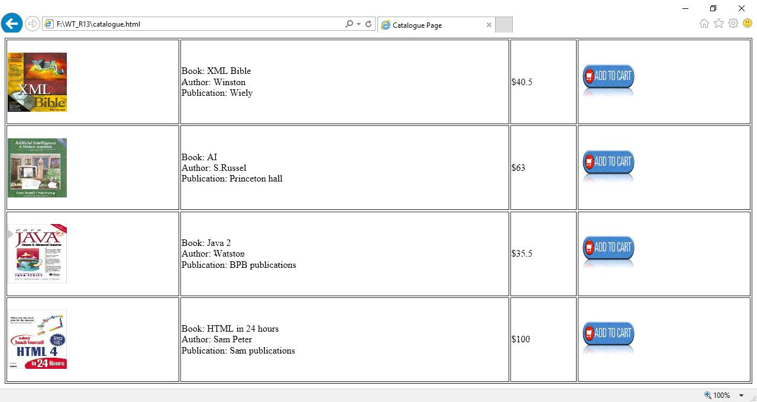

Ch. Vijayananda Ratnam@Dept. Of Computer Science | 7

Web Technologies Lab Manual as per JNTUK-R13

cat_mca.html

<html>
<head>
<title> MCA Catalogue Page</title>

</head>
<body>
<table width="100%" height="100%" border="1">
<tr>

<td><img src="xmlb.gif" height="100" width="100"/></td>
<td>Book: XML Bible
<br>Author: Winston
<br>Publication: Wiely</td>

<td>$40.5</td>
<td><img src="adc.gif" height="100" width="100"/></td>
</tr>
<tr>

<td><img src="html.gif" height="100" width="100"/></td>
<td>Book: HTML in 24 hours
<br>Author: Sam Peter
<br>Publication: Sam publications</td>

<td>$100</td>
<td><img src="adc.gif" height="100" width="100"/></td>
</tr>
</table>

</body>
</html>

OUTPUT:
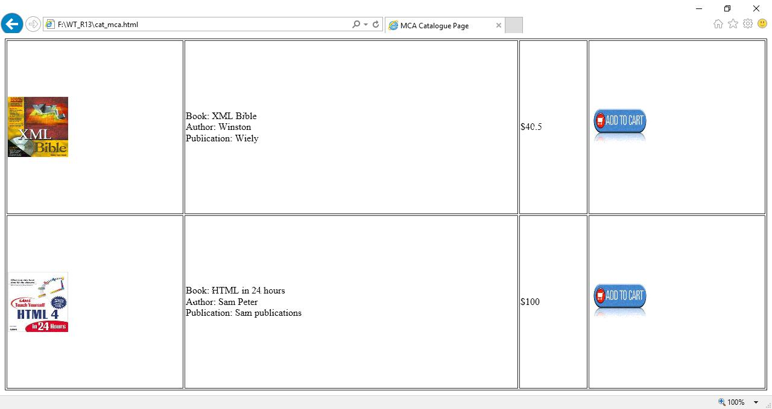

Ch. Vijayananda Ratnam@Dept. Of Computer Science | 8

Web Technologies Lab Manual as per JNTUK-R13

cat_bca.html

<html>
<head>
<title> BCA Catalogue Page</title>

</head>
<body>
<table width="100%" height="100%" border="1">
<tr>

<td><img src="xmlb.gif" height="100" width="100"/></td>
<td>Book: XML Bible
<br>Author: Winston
<br>Publication: Wiely</td>

<td>$40.5</td>
<td><img src="adc.gif" height="100" width="100"/></td>
</tr>
<tr>

<td><img src="ai.gif" height="100" width="100"/></td>
<td>Book: AI
<br>Author: S.Russel
<br>Publication: Princeton hall</td>

<td>$63</td>
<td><img src="adc.gif" height="100" width="100"/></td>
</tr>
</table>

</body>
</html>

OUTPUT:
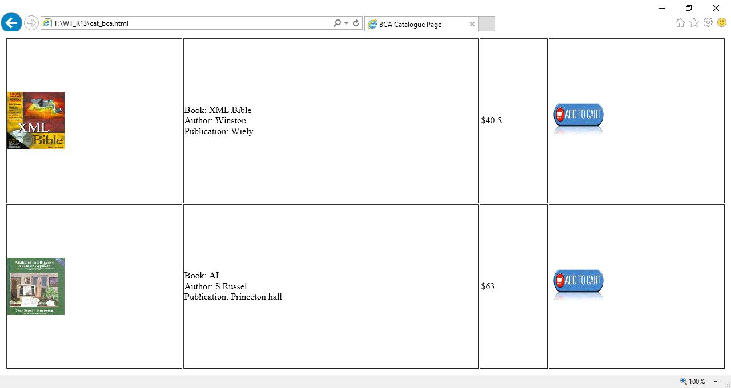

Ch. Vijayananda Ratnam@Dept. Of Computer Science | 9

Web Technologies Lab Manual as per JNTUK-R13

4. REGISTRATION PAGE:

Create a “registration form “with the following fields

- Name (Text field)
- Password (password field)
- E-mail id (text field)

- Phone number (text field)
- Sex (radio button)
- Date of birth (3 select boxes)
- Languages known (check boxes – English, Telugu, Hindi, Tamil)

- Address (text area)

registration.html

<html>
<head>
<title>Registration Page</title>
</head>

<body>
<center>
<h3 align="center"><u>REGISTRATION PAGE</u></h3>
<table border="3">

<tr><td>
<form name="f1" action="" method="post" onsubmit="">
<table cellspacing="10" cellpadding="5">
<tr><td>NAME</td><td><input type="text" size="30" name="uname"/></td></tr>

<tr><td>PASSWORD</td><td><input type="password" size="30" name="pass"/></td></tr>
<tr><td>E-MAIL ID</td><td><input type="text" size="30" name="email"/></td></tr>
<tr><td> PHONE NUMBER</td><td><input type="text" size="15" name="phone"/></td></tr>
<tr><td>GENDER</td><td><input type="radio" name="gen" value="m" />MALE

<input type="radio" name="gen" value="f" />FEMALE </td></tr> <tr><td>DATE OF BIRTH</td>

<td><select name="day">
<option value="day">DAY</option>

<option value="1">1</option>
<option value="2">2</option>
<option value="3">3</option>
<option value="4">4</option>
<option value="5">5</option>

<option value="6">6</option>
<option value="7">7</option>
<option value="8">8</option>
<option value="9">9</option>

<option value="10">10</option>
<option value="11">11</option>
<option value="12">12</option>
<option value="13">13</option>

<option value="14">14</option>
<option value="15">15</option>
<option value="16">16</option>
<option value="17">17</option>

<option value="18">18</option>
<option value="19">19</option>
<option value="20">20</option>
<option value="21">21</option>

<option value="22">22</option>
<option value="23">23</option>
<option value="24">24</option>
<option value="25">25</option>

<option value="26">26</option>
<option value="27">27</option>
<option value="28">28</option>
<option value="29">29</option>

<option value="30">30</option>
<option value="31">31</option>
</select>
<select name="month">

<option value="month">MONTH</option>
<option value="jan">JANUARY</option>
<option value="feb">FEBRUARY</option>
<option value="mar">MARCH</option>

Ch. Vijayananda Ratnam@Dept. Of Computer Science | 10

Web Technologies Lab Manual as per JNTUK-R13

<option value="apr">APRIL</option>

<option value="may">MAY</option>
<option value="jun">JUNE</option>
<option value="jul">JULY</option>
<option value="aug">AUGUST</option>

<option value="sep">SEPTEMBER</option>
<option value="oct">OCTOBER</option>
<option value="nov">NOVEMBER</option>
<option value="dec">DECEMBER</option>

</select>
<select name="year">
<option value="year">YEAR</option>
<option value="1986">1986</option>

<option value="1987">1987</option>
<option value="1988">1988</option>
<option value="1989">1989</option>
<option value="1990">1990</option>

<option value="1991">1991</option>
<option value="1992">1992</option>
<option value="1993">1993</option>
<option value="1994">1994</option>

<option value="1995">1995</option>
<option value="1996">1996</option>
<option value="1997">1997</option>
<option value="1998">1998</option>

<option value="1999">1999</option>
<option value="2000">2000</option>
<option value="2001">2001</option>
<option value="2002">2002</option>

<option value="2003">2003</option>
<option value="2004">2004</option>
<option value="2005">2005</option>
<option value="2006">2006</option>

<option value="2007">2007</option>
<option value="2008">2008</option>
<option value="2009">2009</option>
<option value="2010">2010</option>
<option value="2011">1980</option>

<option value="2012">1981</option>
<option value="2013">1982</option>
<option value="2014">1983</option>
</select></td></tr>

<tr><td>LANGUAGES KNOWN</td>
<td>

<input type="checkbox" value="eng" name="lang" />ENGLISH <input type="checkbox" value="tel" name="lang" />TELUGU <input type="checkbox" value="hin" name="lang" />HINDI <input type="checkbox" value="tam" name="lang" />TAMIL
</td></tr>
<tr>

<td>ADDRESS</td>
<td><textarea name="addr" cols="25" rows="5"></textarea></td></tr>
<tr><td colspan="2" align="center"><input type="submit" value="SUBMIT"/>
&nbsp;&nbsp;&nbsp;&nbsp;&nbsp;&nbsp;<input type="reset" value="RESET" /></td>

</tr>
</table>
</form>
</td></tr></table>

</center>
</body>
</html>

Ch. Vijayananda Ratnam@Dept. Of Computer Science | 11

Web Technologies Lab Manual as per JNTUK-R13

OUTPUT:
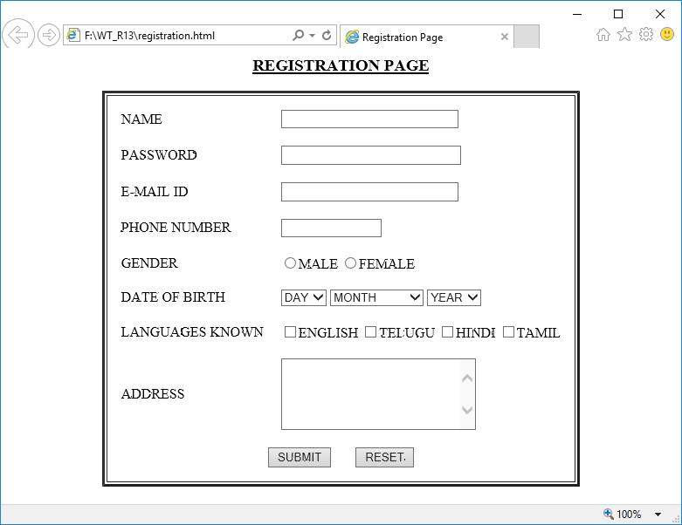

Ch. Vijayananda Ratnam@Dept. Of Computer Science | 12

Web Technologies Lab Manual as per JNTUK-R13

5. Design a web page using CSS (Cascading Style Sheets) which includes the following:

A. Use different font, styles: In the style definition you define how each selector should work (font, color etc.).

Then, in the body of your pages, you refer to these selectors to activate the styles.

styles.css

h1
{

color:red;
font-family:caStellar;
font-size:22pt;
text-decoration:underline;

}
h2
{
color:blue;

font-family:Chiller;
font-size:18pt;
text-decoration:overline;
}

p
{
color:magenta;
font-family:Trebuchet MS;

font-size:14pt;
font-style:italic;
}

fontstyles.html

<html>
<head>

<title>Usage of different font,styles and colors </title>
<link rel="stylesheet" type="text/css" href="styles.css"/>
</head>
<body>
<h1>This header is in red</h1>

<h2>This header is in blue</h2>
<p>This is normal text</p>
</body>
</html>
OUTPUT:
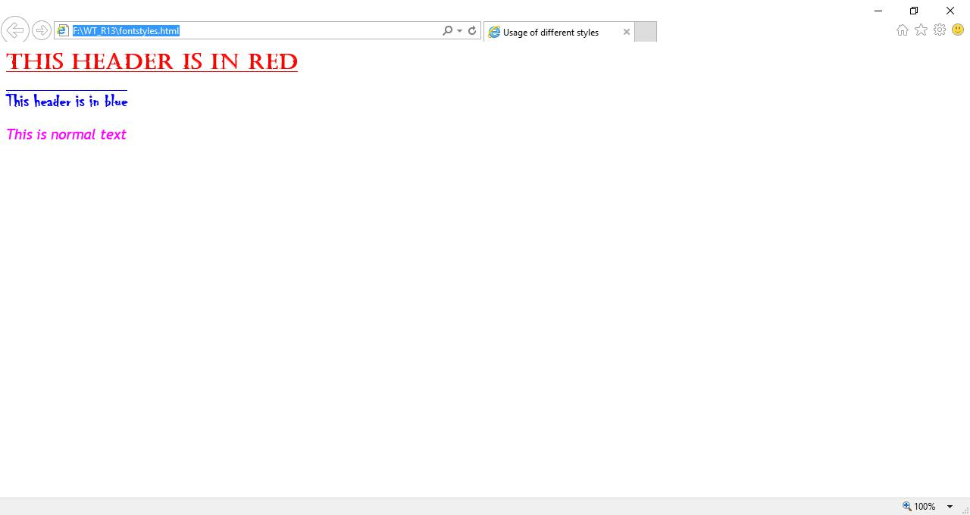

Ch. Vijayananda Ratnam@Dept. Of Computer Science | 13

Web Technologies Lab Manual as per JNTUK-R13

B. Set a background image for both the page and single elements on the page.

bg_image.html

<html>

<head>
<title>Setting background image</title>
<style type="text/css">
body

{
background-image:url("img11.jpg");

}

</style>
</head>
<body text="#ee78a2">
<h1>Life is beautiful!!!</h1>

</body>
</html>

OUTPUT:


Ch. Vijayananda Ratnam@Dept. Of Computer Science | 14

Web Technologies Lab Manual as per JNTUK-R13

C. Control the repetition of the image with the background-repeat property.

bg_repeat.html

<html>

<head>
<title>Controlling background image</title>
<style type="text/css">
body

{
background-image:url("img11.jpg");
background-repeat:no-repeat
}

</style>
</head>
<body text="#fe78a2">
<h1>Life is beautiful!!!</h1>

</body>
</html>

OUTPUT


Ch. Vijayananda Ratnam@Dept. Of Computer Science | 15

Web Technologies Lab Manual as per JNTUK-R13

- Write an XML file which will display the Book information which includes the following:

  - Title of the book
  - Author Name
  - ISBN number
  - Publisher name

  - Edition
  - Price
Write a Document Type Definition (DTD) to validate the above XML file.

catalog.dtd

<!ELEMENT Catalog (Book)*>
<!ELEMENT Book (Title, Author, Publication ,Edition, ISBN, Price)>
<!ELEMENT Title (#PCDATA)>
<!ELEMENT Publication (#PCDATA)>
<!ELEMENT Edition (#PCDATA)>

<!ELEMENT ISBN (#PCDATA)>
<!ELEMENT Price (#PCDATA)>

library.css

Catalog

{
font-family:arial;
color:blue;

font-size:16pt
}
Book
{

font-family:times new roman;
color:blue;
table-layout:auto;

font-size:14pt
}
Title
{

font-family:arial;
color:green;
margin-left:20pt;
font-size:12pt

}
Author
{
font-family:arial;

color:magenta
}
Publication,Edition,ISBN,Price
{

display:block;
font-family:arial;
color:black;
font-size:10pt;

margin-left:40pt
}

Cataloguedemo.xml

<?xml version="1.0" encoding="UTF-8" standalone=”no”?> <?xml-stylesheet type="text/css" href="library.css" ?>
<!DOCTYPE Catalog SYSTEM "catalog.dtd">

<Catalog">

<Book>
<Title>XML Bible</Title>
<Author>Winston</Author>

Ch. Vijayananda Ratnam@Dept. Of Computer Science | 16

Web Technologies Lab Manual as per JNTUK-R13

<Publication>Wiely</Publication>

<Edition>Fifth Edition</Edition>
<ISBN>0-7645-4760-7</ISBN>
<Price>$40.5</Price >
</Book>

<Book>
<Title>Artificial Intelligence</Title>
<Author>S. Russel</Author>

<Publication> Princeton Hall </Publication>
<Edition> Sixth Edition</Edition>
<ISBN> 0-13-1038-5-2 </ISBN>
<Price>$63</Price>

</Book>

<Book>
<Title>Java 2</Title>

<Author>Watson</Author>
<Publication>BPB Publications</Publication>
<Edition>Third Edition</Edition>
<ISBN>0-41-1058-7-2</ISBN>

<Price>$63</Price>
</Book>

<Book>

<Title>HTML in 24 hours </Title>
<Author> Sam Peter</Author>
<Publication> SAM Publications </Publication>
<Edition>Fifth Edition</Edition>

<ISBN> 0-672-32841-0 </ISBN>
<Price> $50 </Price >
</Book>
</Catalog>

OUTPUT:
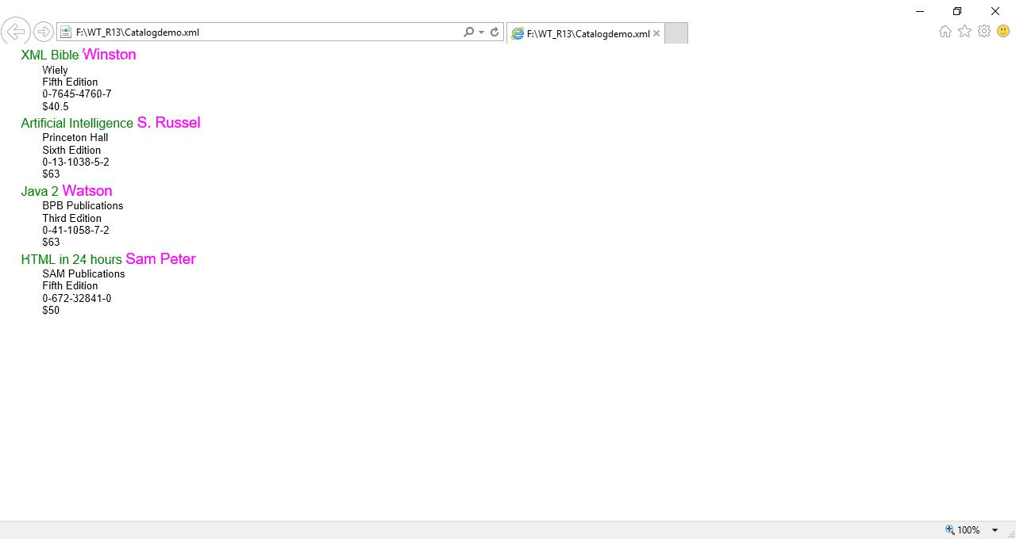

Ch. Vijayananda Ratnam@Dept. Of Computer Science | 17

Web Technologies Lab Manual as per JNTUK-R13

- Write Ruby program reads a number and calculates the factorial value of it and prints the same. fact.rb

puts "Enter a number>>"

- = gets.to_i f=1
i=1

while i<=n do f = f*i

i= i+1 end

puts "factorial of #{n} is #{f}"

OUTPUT
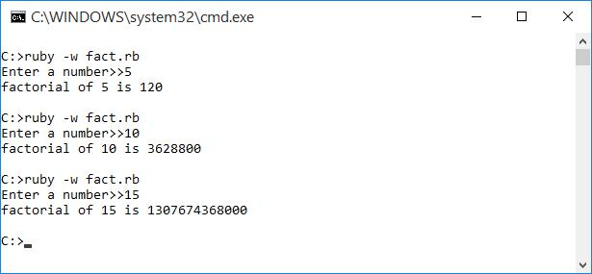

- Write a Ruby program which counts number of lines in a text file using its regular expressions facility lines.rb

print "Enter file name:";
fname = gets.chomp;
count = IO.readlines(fname).size
puts "There are #{count} lines in #{fname}";

OUTPUT:
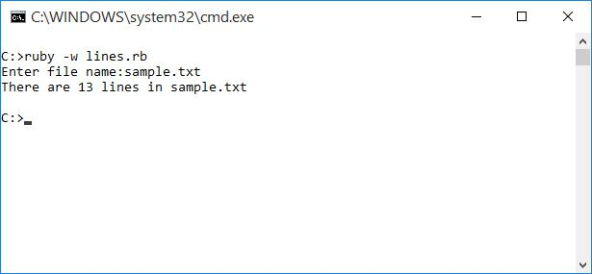

Ch. Vijayananda Ratnam@Dept. Of Computer Science | 18

Web Technologies Lab Manual as per JNTUK-R13

- Write a Ruby program that uses iterator to find out the length of a string. iterator.rb

print "Enter a string:"

str = gets.chomp
c=0
str.each_char do |i|
c=c+1

end
puts "Length of #{str}: #{c}"

OUTPUT
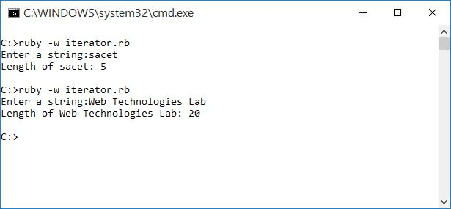

- Write simple Ruby programs that uses arrays in Ruby. bsort.rb

puts "Bubble Sort"

puts "==========="

print "Enter the size of the array:"
n=gets.to_i

a=Array.new(n)
puts "Enter the elements :"
for i in 0..n-1
a[i]=gets.to_i

end

#Bubble sort Algorithm
t=0

for i in 0..n-1
for j in i..n-1
if (a[i] > a[j])
t=a[j]

a[j]=a[i]
a[i]=t
end
end

end

puts "After Sorting :"
for i in 0..n-1

print "#{a[i]} "
end

Ch. Vijayananda Ratnam@Dept. Of Computer Science | 19

Web Technologies Lab Manual as per JNTUK-R13

OUTPUT:
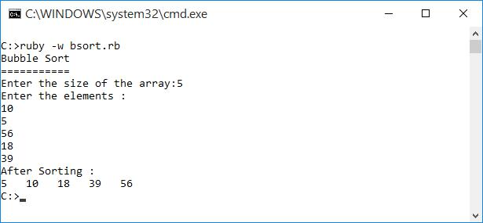

- Write programs which uses associative arrays concept of Ruby. assoc.rb

creators = Hash.new;

creators = {"Vaccine"=>"Paschar","Dynamite"=>"Nobel","Toilet"=>"Creeper"}; size = creators.length;
puts "Size of hash is: #{size}";
creators.each do |key,val|

puts "#{key} invented by #{val}"
end

OUTPUT:
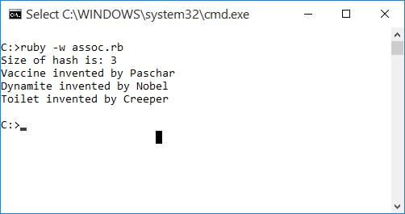

Ch. Vijayananda Ratnam@Dept. Of Computer Science | 20

Web Technologies Lab Manual as per JNTUK-R13

- Write Ruby program which uses Math module to find area of a triangle. area.rb

print "Enter a,b,c values:"

a=gets.to_i
b=gets.to_i
c=gets.to_i
s = (a+b+c)/2

area = Math.sqrt(s*(s-a)*(s-b)*(s-c)).round(2)
print "Area of Triangle=#{area}"

OUTPUT:
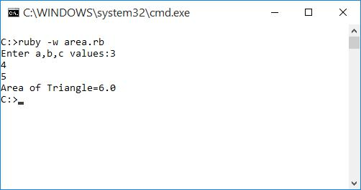

- Write Ruby program which uses tk module to display a window window.rb

require 'tk'

root = TkRoot.new { title "GUI Window" }

TkLabel.new(root) do
text 'Hello, World!'
pack("side" => "right", "padx"=> "100", "pady"=> "100")
end

Tk.mainloop

OUTPUT:
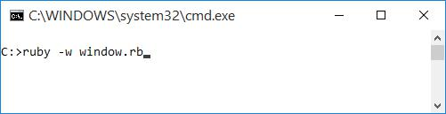

Ch. Vijayananda Ratnam@Dept. Of Computer Science | 21

Web Technologies Lab Manual as per JNTUK-R13
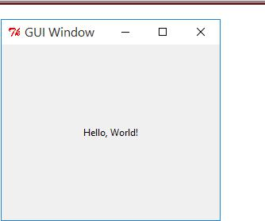

Ch. Vijayananda Ratnam@Dept. Of Computer Science | 22

Web Technologies Lab Manual as per JNTUK-R13

- Define Complex class in Ruby and do write methods to carry operations on Complex objects. Cmplx.rb

class Cmplx

attr_accessor :real, :imag

def read
@real=gets.to_i

@imag=gets.to_i
end

def add(other)

ob = Cmplx.new
ob.real = @real+other.real;
ob.imag = @imag+other.imag;
return ob

end

def subtract(other)
ob = Cmplx.new;

ob.real = @real-other.real;
ob.imag = @imag-other.imag;
return ob;
end

def multiply(other)
ob = Cmplx.new
ob.real = (@real * other.real)-(imag*other.imag);

ob.imag = (@real * other.imag)+(imag*other.real);
return ob;
end

def divide(other)
t = Cmplx.new;
ob = Cmplx.new;
t.imag = -other.imag;

- =(other.real).abs; i =(other.imag).abs; d =(r*r)+(i*i);

ob.real = ((@real * other.real)-(imag*t.imag))/d; ob.imag = ((@real * t.imag)+(imag*other.real))/d; return ob;

end

def disp

if @imag<0
puts "#{@real}#{@imag}i"
else
puts "#{@real}+#{@imag}i"

end
end
end

t1 = Cmplx.new
t2 = Cmplx.new
t3 = Cmplx.new
t4 = Cmplx.new

t5 = Cmplx.new
t6 = Cmplx.new

puts "Enter first number"

t1.read

puts "Enter Second number"
t2.read

print "FIRST NUMBER:"
t1.disp

Ch. Vijayananda Ratnam@Dept. Of Computer Science | 23

Web Technologies Lab Manual as per JNTUK-R13

print "SECOND NUMBER:"

t2.disp
print "=================\n";

print "ADDITION:"

t3 = t1.add(t2)
t3.disp

print "SUBTRACTION:"

t4 = t1.subtract(t2)
t4.disp

print "PRODUCT:"

t5 = t1.multiply(t2)
t5.disp

print "DIVSION:"

t6 = t1.divide(t2)
t6.disp
print "=================";

OUTPUT:
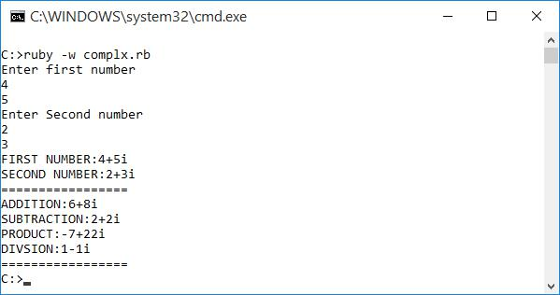

Ch. Vijayananda Ratnam@Dept. Of Computer Science | 24

Web Technologies Lab Manual as per JNTUK-R13

- Write a program which illustrates the use of associative arrays in Perl. pAssoc.pl

%ages = ('kiran'=>19,'vijay'=>21,'raju'=>20);

print"Original Array:\n";
print"===========================\n";
while (($key) = each %ages)
{

print "$key is $ages{$key} years old\n ";
}
$ages{'mayur'} = 24;
print"\nAfter adding element:\n";

print"===========================\n";
while(($key) = each %ages)
{
print "$key is $ages{$key} years old\n ";

}
delete( $ages{'vijay'});
print"\nAfter deleting element:\n";
print"===========================\n";

@all_keys = keys(%ages);
print "Keys are: @all_keys\n";
@all_values = values(%ages);
print "Values are: @all_values";

OUTPUT:
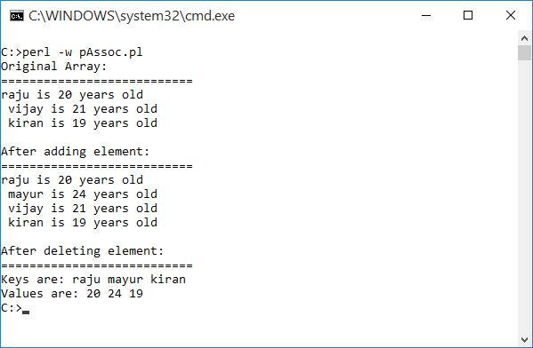

Ch. Vijayananda Ratnam@Dept. Of Computer Science | 25

Web Technologies Lab Manual as per JNTUK-R13

- Write Perl program takes a set names along the command line and prints whether they are regular files or special files

fileTest.pl

$len = @ARGV;
for ($i=0;$i<$len;$i++)
{
if(-e $ARGV[$i])

{
if(-T $ARGV[$i])
{
print "$ARGV[$i] is a text file\n";

}
else
{
print "$ARGV[$i] is a special file\n";

}
}
else
{

print "$ARGV[$i] does not exists";
}
}

OUTPUT:
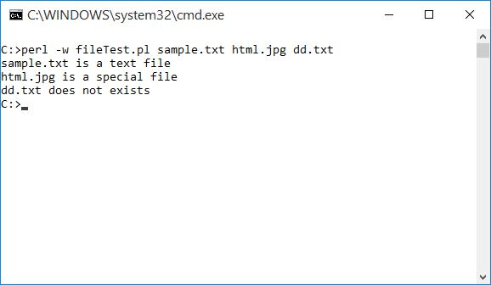

Ch. Vijayananda Ratnam@Dept. Of Computer Science | 26

Web Technologies Lab Manual as per JNTUK-R13

- Write a Perl program to implement UNIX „passwd’ program unixPw.pl

my $salt='';

my $encrypted='';
my $password='';
my $use = 'Usage: Please provide password for encrypt';
my @saltchars=('.', '/', 0..9, 'A'..'Z', 'a'..'z');

my $args=@ARGV;
if ( $args < 1 || $args > 2 )
{
print "$use\n";

exit;
}
$password=$ARGV[0];
if( $args == 1 )

{
$salt = join('',@saltchars[rand(64),rand(64)]);
}
else

{
$salt=$ARGV[1];
}
$encrypted=crypt($password,$salt);

print "$password --> $encrypted\n";

OUTPUT:
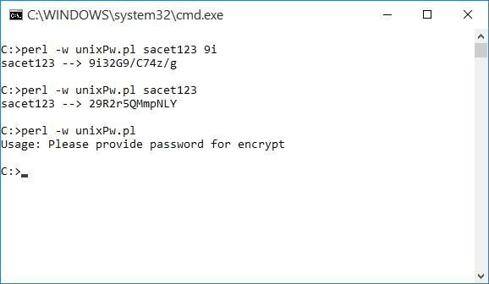

Ch. Vijayananda Ratnam@Dept. Of Computer Science | 27

Web Technologies Lab Manual as per JNTUK-R13

- An example Perl program to connect to a MySQL Database table and executing simple commands. Note: Create the following table in MySQL and insert some data in to the table.

students table

create table students
(
roll varchar(3) not null,
name varchar(3) not null,

branch varchar(3) not null
);

dbConn.pl

use DBI;

#definition of variables

$db="test";
$host="localhost";
$user="root";
$password="";

#connect to MySQL database

my $dbh = DBI->connect ("DBI:mysql:database=$db:host=$host",$user,$password) or die "Can't connect to database: $DBI::errstr\n";

#prepare the query
my $sth = $dbh->prepare( "SELECT *FROM students");

#execute the query
$sth->execute();

## Retrieve the results of a row of data and print

print "\tQuery results:\n=====================\n"; print("ROLL\tNAME\tBRANCH\n=====================\n"); while (my @row = $sth->fetchrow_array()) {
print "@row\n";

}

warn "Problem in retrieving results", $sth->errstr( ), "\n" if $sth->err(); exit;

OUTPUT:
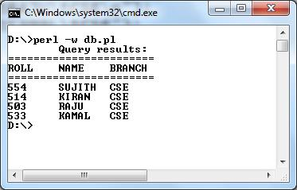

Ch. Vijayananda Ratnam@Dept. Of Computer Science | 28

Web Technologies Lab Manual as per JNTUK-R13

- Example PHP program for contacts page. contacts.php

<?php

if(isset($_REQUEST['vname']))
{
$vname=$_REQUEST['vname'];
$email=$_REQUEST['email'];

$message=$_REQUEST['message'];
$from="From: $vname<$email>\r\nReturn-path: $email";
$subject="Message sent using your contact form";

$m = mail("youremail@yoursite.com", $subject, $message, $from); if($m)
echo "<h1>Email sent!";
else
echo "Send Failed:".mysql_error();

echo "&nbsp;&nbsp;&nbsp;<a href='contacts.php'>[Back to Contacts]</a>";
}
else { ?>
<html>

<head>
<title>Contacts Page</title>
</head>
<body>

<font face="Trebuchet ms" size="6">
<table border="1">
<tr><th>Contact Us</th></tr>
<tr><td>

<form action="contacts.php" method="POST" enctype="multipart/form-data"> Your name<br/>

<input type="text" name="vname" value="" size="30"/><br> Your email<br>

<input type="text" name="email" value="" size="30"/><br> Your message<br>

<textarea name="message" rows="7" cols="30"></textarea><br> <input type="submit" value="Send email"/>
</form>

</td></tr>
</table>
</body>
</html>

<?php } ?>

OUTPUT:

Ch. Vijayananda Ratnam@Dept. Of Computer Science | 29

Web Technologies Lab Manual as per JNTUK-R13
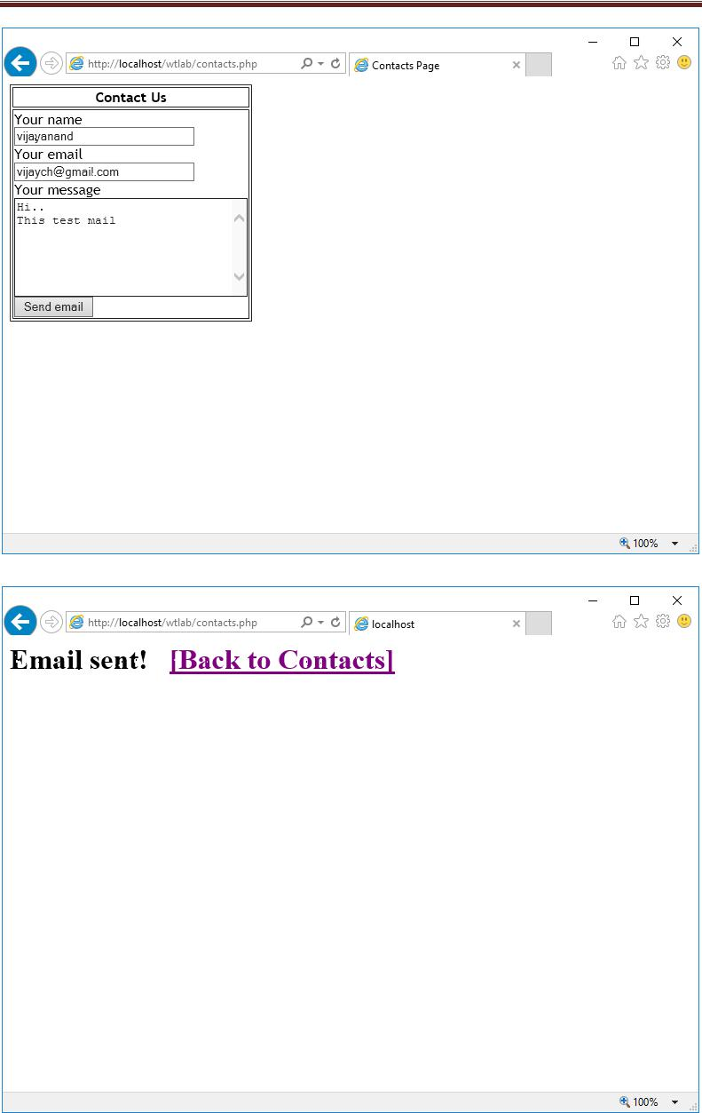

Ch. Vijayananda Ratnam@Dept. Of Computer Science | 30

Web Technologies Lab Manual as per JNTUK-R13

20. User Authentication:

- Assume four users user1, user2, user3 and user4 having the passwords pwd1,pwd2,pwd3 and pwd4 respectively. Write a PHP for doing the following.

  - Create a Cookie and add these four user ID‟s and passwords to this Cookie.
  - Read the user id and passwords entered in the Login form (week1) and authenticate with the

values (user id and passwords) available in the cookies.

If he is a valid user (i.e., user-name and password match) you should welcome him by name (user-name) else you should display “You are not an authenticated user‟‟

login.html

<html>
<head>

<title>Login Page</title>
</head>
<body>
<center>

<h3> Login Page</h3>

<form name="f1" action="setcookie.php" method="post"> <table frame="border">

<tr>

<td>User</td>

<td><input type="text" name="user" size="20" value=""/></td> </tr>

<tr>

<td>Password</td>

<td><input type="password" name="pwd" size="20" value=""/></td> </tr>

<tr>

<td align="center" colspan="2"><input type="submit" value="Sign in"/> <input type="reset" /></td>

</tr>
</table>

</form>
</body></center>
</html>

setcookie.php

<html>
<head>
<title>Set Cookie</title>

</head>
<body>
<?php
$user = $_POST['user'];

$pwd = $_POST['pwd'];
setcookie("user",$user,time()+3600*2);
setcookie("pwd",$pwd,time()+3600*2);
echo "<h3>The Cookie Added...</h3>";

?>
</body>
</html>

Ch. Vijayananda Ratnam@Dept. Of Computer Science | 31

Web Technologies Lab Manual as per JNTUK-R13

getcookie.php

<html>
<head>

<title>Get Cookie</title>
</head>
<body>
<?php

$user = $_COOKIE['user'];
$pwd = $_COOKIE['pwd'];
if($user=="user1")

{
if($pwd == "pwd1")
echo "<h2>Welcome User1 </h2>";
else

echo "<h2>You are not an authenticated user.</h2>";
}
elseif($user=="user2")
{

if($pwd == "pwd2")
echo "<h2>Welcome User2</h2>";
else
echo "<h2>You are not an authenticated user.</h2>";

}
elseif($user=="user3")
{
if($pwd == "pwd3")

echo "<h2>Welcome User3</h2>";
else
echo "<h2>You are not an authenticated user.</h2>";
}

elseif($user=="user4")
{
if($pwd == "pwd4")
echo "<h2>Welcome User4</h2>";
else

echo "<h2>You are not an authenticated user.</h2>";
}
else
echo "<h2>Invalid Username/Password</h2>";

?>
</body>
</html>

Ch. Vijayananda Ratnam@Dept. Of Computer Science | 32

Web Technologies Lab Manual as per JNTUK-R13

OUTPUT 1 for Valid User:
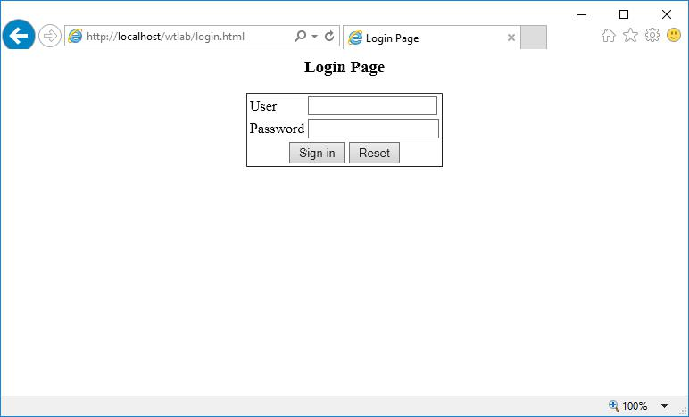
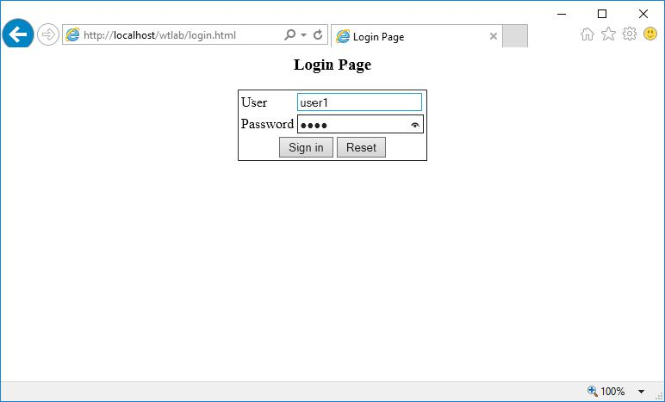

Ch. Vijayananda Ratnam@Dept. Of Computer Science | 33

Web Technologies Lab Manual as per JNTUK-R13
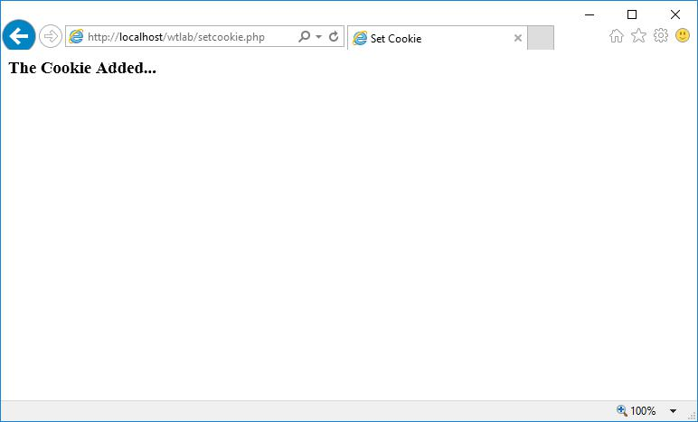
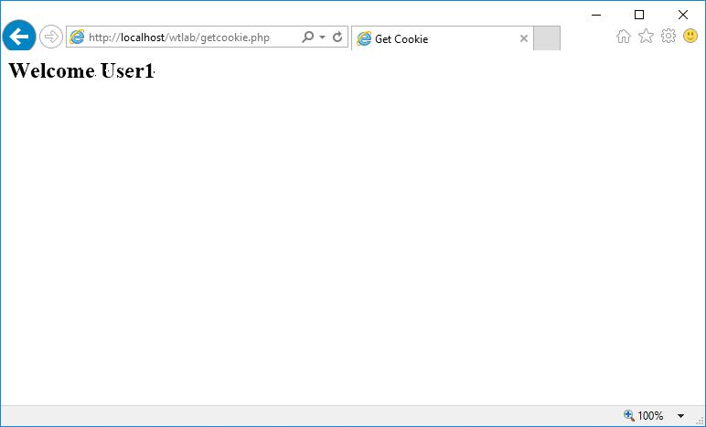

Ch. Vijayananda Ratnam@Dept. Of Computer Science | 34

Web Technologies Lab Manual as per JNTUK-R13

OUTPUT 2 for Invalid User:
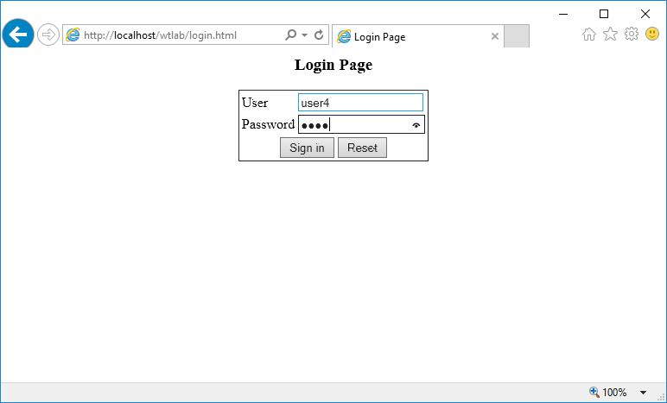
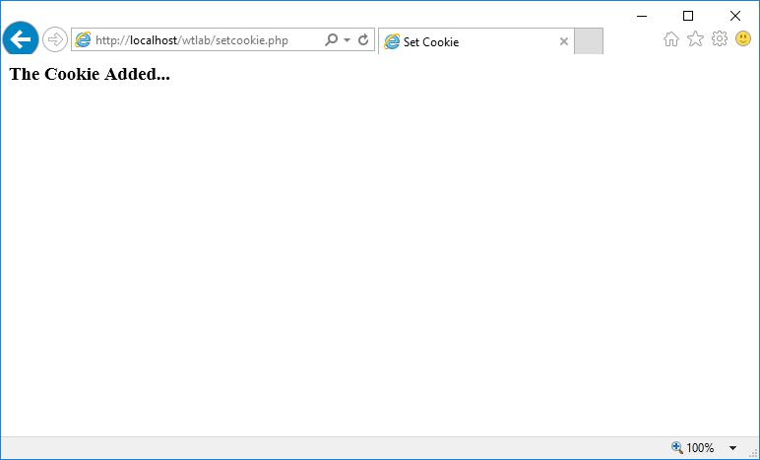

Ch. Vijayananda Ratnam@Dept. Of Computer Science | 35

Web Technologies Lab Manual as per JNTUK-R13
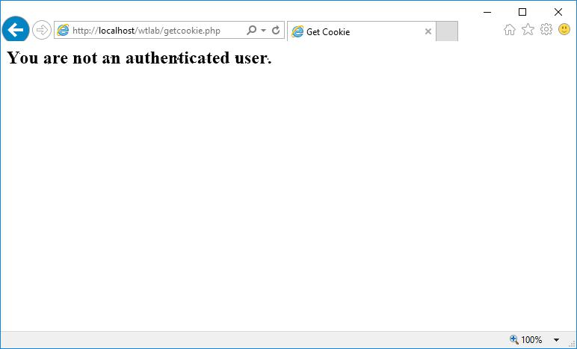

OUTPUT 3 for Non-existing user:
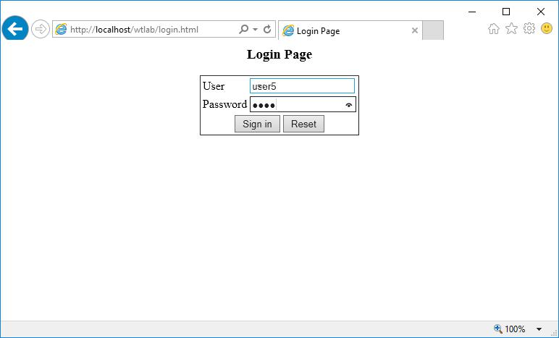

Ch. Vijayananda Ratnam@Dept. Of Computer Science | 36

Web Technologies Lab Manual as per JNTUK-R13
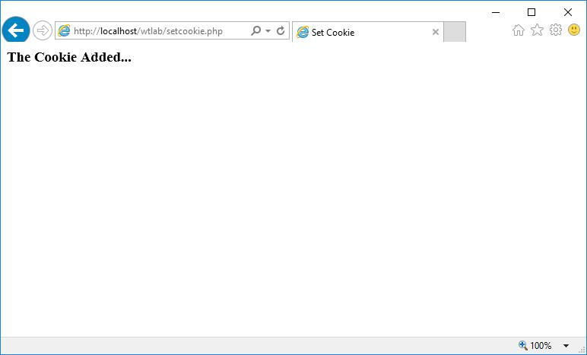
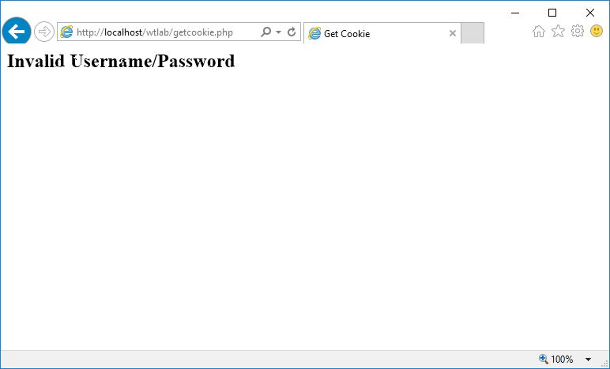

Ch. Vijayananda Ratnam@Dept. Of Computer Science | 37

Web Technologies Lab Manual as per JNTUK-R13

- AIM: Use init-parameters to do the above task. Store the user-names and passwords in the “users.ini” file and access them in php page by using the “parse_ini_file()” method.

mylogin.html

<html>
<head>

<title>Login Page</title>
</head>
<body>
<center>
<h3> Login Page</h3>

<form name="f1" action="initparam.php" method="post">
<table frame="border">
<tr>
<td>User</td>

<td><input type="text" name="user" size="20" value=""/></td> </tr>

<tr>
<td>Password</td>

<td><input type="password" name="pwd" size="20" value=""/></td> </tr>

<tr>

<td align="center" colspan="2"><input type="submit" value="Sign in"/> <input type="reset" /></td>
</tr>
</table>
</form>

</body></center>
</html>

users.ini

;This is a users .ini file

[first_section]
u1=user1
p1=pwd1

initparam.php

<html>
<head>

<title>Init Parameters</title>
</head>
<body>

<?php

$user = $_POST['user'];
$pwd = $_POST['pwd'];
$temp = parse_ini_file("users.ini");
foreach($temp as $value)

{
$users[] = $value;
}
if($user==$users[$i])

{
if($pwd==$users[$i+1])
echo "<h3>Welcome $users[$i]</h3>";
else

echo "<h3>You are not an authenticated user</h3>";
}
else
echo "<h3>Invalid Username/Password</h3>";

}
?>
</body>
</html>

Ch. Vijayananda Ratnam@Dept. Of Computer Science | 38

Web Technologies Lab Manual as per JNTUK-R13

OUTPUT for Valid user:
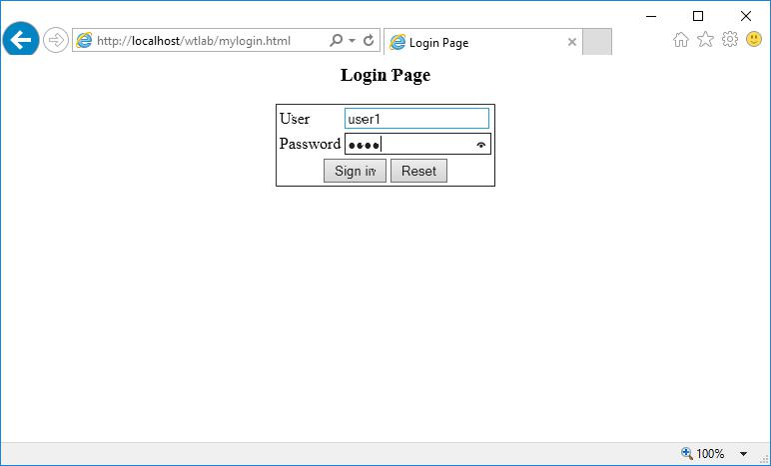
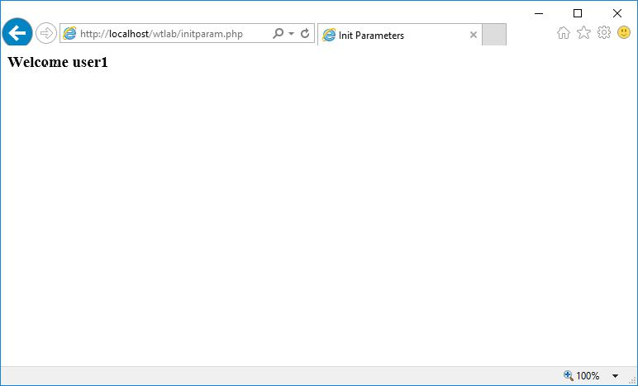

Ch. Vijayananda Ratnam@Dept. Of Computer Science | 39

Web Technologies Lab Manual as per JNTUK-R13

OUTPUT for Invalid user:
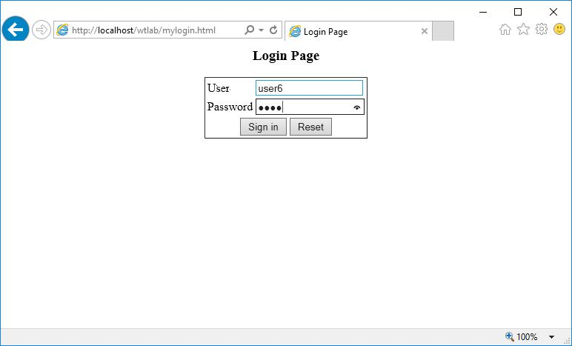
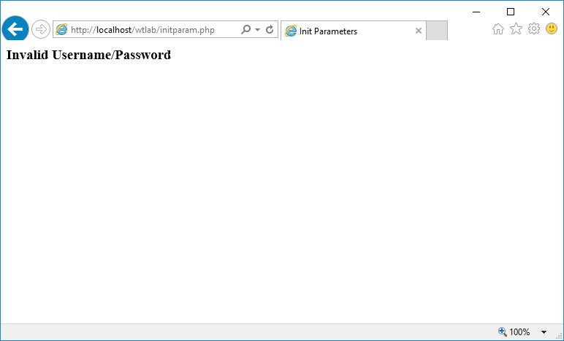

Ch. Vijayananda Ratnam@Dept. Of Computer Science | 40

Web Technologies Lab Manual as per JNTUK-R13

- Example PHP program for registering users of a website and login. registration1 table:

CREATE TABLE registration1

(
uname varchar(25) NOT NULL,
pass varchar(25) NOT NULL,
email varchar(25) NOT NULL,

phno bigint(10) NOT NULL,
gender varchar(6) NOT NULL,
dob char(10) NOT NULL,
languages varchar(25) NOT NULL,

address varchar(75) NOT NULL,
UNIQUE KEY (uname)
);

A) Registration: Add the following code to registration.html in <head> section:

<script language="javascript">
function validate()

{
var nam = document.f1.uname.value;
if(nam=="")
{

alert("Please enter name");
document.f1.uname.focus();
return false;
}

var pwd = document.f1.pass.value;
if(pwd=="")
{

alert("Please enter Password");
document.f1.pass.focus();
return false;
}

var email = document.f1.email.value;
if(email=="")
{
alert("Please enter youe email");

document.f1.email.focus();
return false;
}

var phno = document.f1.phone.value;
len=phno.length
if(phno=="" || len != 10)
{

alert("Please enter phno or should be strictly 10 digits");
document.f1.phone.focus();
return false;
}

var genders = document.getElementsByName("gen");
var selectedGender="";
for(var i = 0; i < genders.length; i++)

{
if(genders[i].checked == true)
selectedGender = genders[i].value;
}

if(selectedGender=="")
{
alert("Please select your gender");
document.f1.gen.focus();

return false;
}

var day = document.f1.day.value;

Ch. Vijayananda Ratnam@Dept. Of Computer Science | 41

Web Technologies Lab Manual as per JNTUK-R13

var month = document.f1.month.value;

var year = document.f1.year.value;
if(day=="day" || month=="month" || year=="year")
{
alert("Please select your DOB");

document.f1.day.focus();
return false;
}

var languages = document.getElementsByName("lang[]");
var selected = new Array();
var j=0;
for(var i = 0; i < languages.length; i++)

{
if(languages[i].checked == true)
selected[j++] = languages[i].value;
}

var len = selected.length;
if(len==0)
{
alert("Please Choose atleast one language");

document.f1.lang.focus();
return false;
}

var addr = document.f1.addr.value;
if(addr=="")
{

alert("Please enter your address");

document.f1.addr.focus();
return false;

}
}

</script>

Then, Modify the <form> tag attributes:

<form name="f1" action="insert.php" method="post" onsubmit="javascript:return validate()">

insert.php

<?php
$conn = mysql_connect("localhost","root","") or die("Failed to Connect:".mysql_error());

mysql_select_db("test",$conn) or die("No Database existing:".mysql_error());
if(isset($_POST['uname']))
{
$uname=$_POST['uname'];

$pass=$_POST['pass'];
$email=$_POST['email'];
$phno=(float)$_POST['phone'];
$gender=$_POST['gen'];

$day=(int)$_POST['day'];
$month=(int)$_POST['month'];
$year=(int)$_POST['year'];
$dob = "$day-$month-$year";

$str=$_POST['lang'];
$lang="";
foreach ($str as $val)

{ $lang = $lang." ".$val;} $text=$_POST['addr'];
$addr = str_replace("\n","<br>",$text);

$query = "INSERT INTO registration1 VALUES ('$uname', '$pass', '$email', '$phno', '$gender', '$dob', '$lang', '$addr')";

$res = mysql_query($query); if($res)

{
$script = "<script>alert('User Registration Successful');";

Ch. Vijayananda Ratnam@Dept. Of Computer Science | 42

Web Technologies Lab Manual as per JNTUK-R13

$script .= "document.writeln('<center><h4><u>User Details</u></h1>');"; $script .= "document.writeln('Your username is:<b> $uname</b><br/>');"; $script .= "document.writeln('Your password is:<b> $pass</b></center>');";

$script .= "document.writeln('<h4 align=right><a href=catalogue.html>[View Books]
</a> </h4>');</script>";

echo $script;
}
else

echo "<script>alert('User Registration Failed'); window.location = 'registration.html'; </script>";
}
?>

OUTPUT
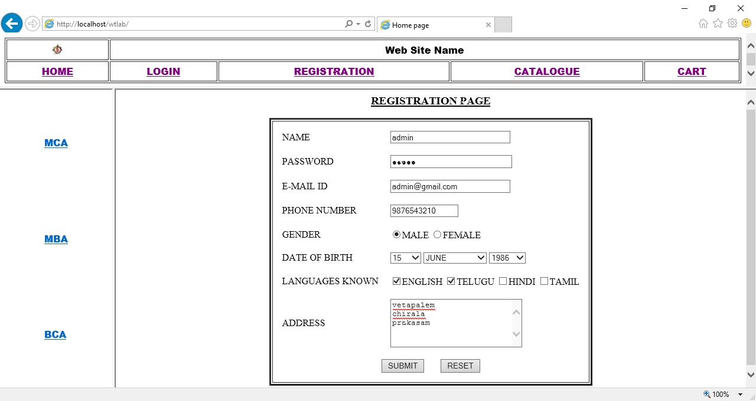

Ch. Vijayananda Ratnam@Dept. Of Computer Science | 43

Web Technologies Lab Manual as per JNTUK-R13
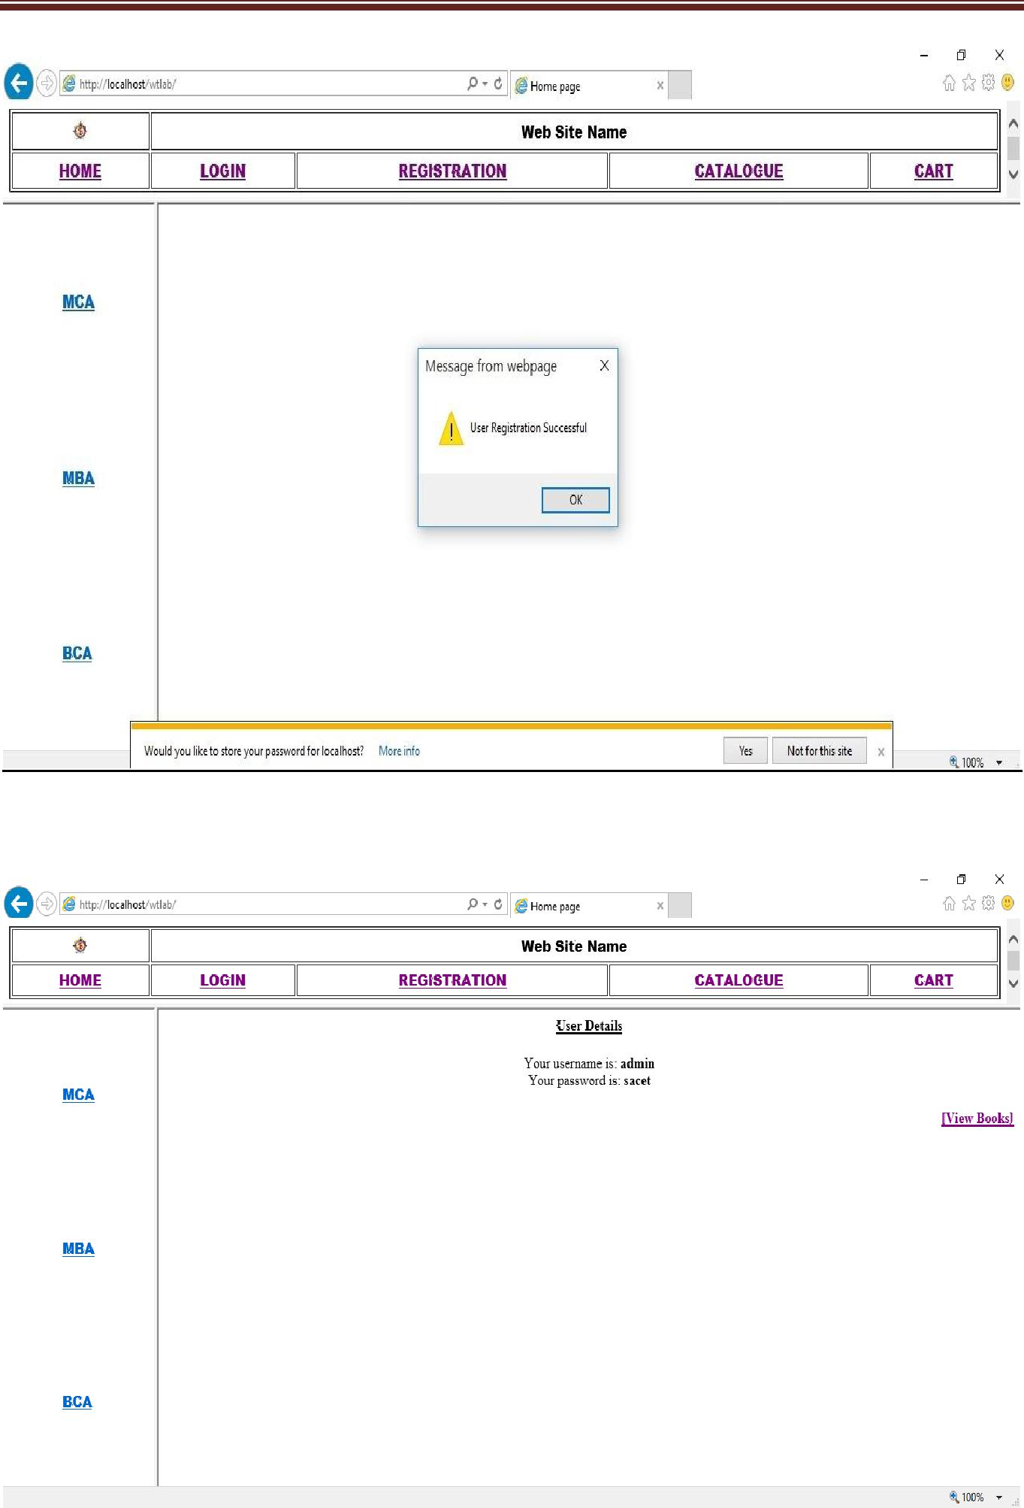

Ch. Vijayananda Ratnam@Dept. Of Computer Science | 44

Web Technologies Lab Manual as per JNTUK-R13
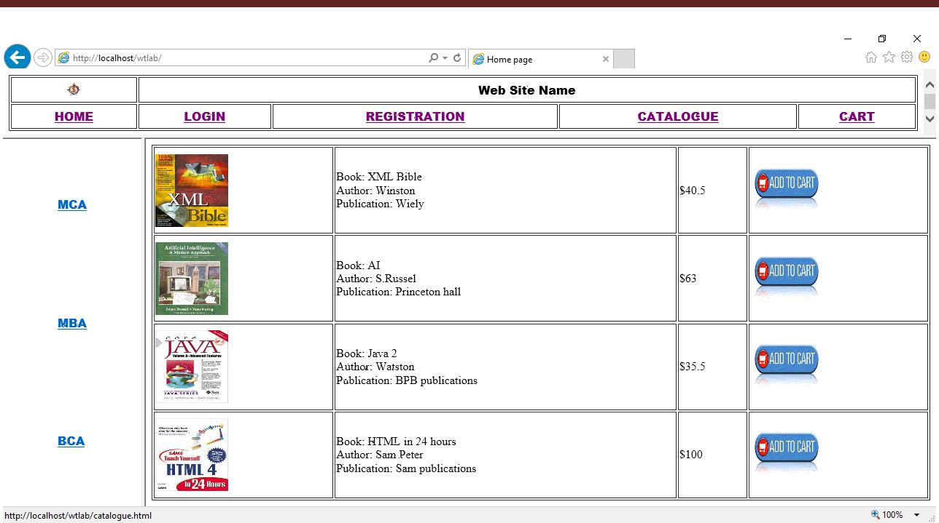

Ch. Vijayananda Ratnam@Dept. Of Computer Science | 45

Web Technologies Lab Manual as per JNTUK-R13

- Login Verification login.html
<html>

<head>
<title> Sign-in Page </title>
<script language="javascript">
function validate()

{
var nam = document.f1.uname.value;
if(nam=="")
{

alert("Please enter name");
document.f1.uname.focus;
return false;
}

var pwd = document.f1.pass.value;
if(pwd=="")
{
alert("Please enter Password");

document.f1.pass.focus;
return false;
}
}

</script>
</head>
<body>
<br/><br/><br/>

<center>
<form name="f1" action="validation.php" method="post" onsubmit="javascript:return
validate()">
<table border="3" cellpadding="0" cellspacing="0">

<tr>
<td>
<table cellspacing="10">
<tr>
<td colspan="2" align="center"><h2><u>Login Page<u></h2></td>

</tr>
<tr>
<td> User Name</td>
<td><input type="text" name="uname" size="15"></td>

</tr>
<tr>
<td> Password</td>

<td><input type="password" name="pass" size="15"></td> </tr>
<tr>

<td align="center"><input type="submit" value="Sign in"></td> <td align="center"><input type="reset" value="Clear"></td>
</tr>
</table>
</td>
</tr>

</table>
</form>
</center>
</body>

</html>

validation.php

<?php

$conn = mysql_connect("localhost","root","") or die("Failed to Connect:".mysql_error());
mysql_select_db("test",$conn) or die("No Database existing:".mysql_error());
if(isset($_POST['uname']))
{

$uname=$_POST['uname'];
$pass=$_POST['pass'];

$res = mysql_query("select * from registration1 where uname='$uname' and pass ='$pass'"); $count=mysql_num_rows($res);

Ch. Vijayananda Ratnam@Dept. Of Computer Science | 46

Web Technologies Lab Manual as per JNTUK-R13

if($count)

echo "<script>alert('Welcome $uname');window.location='catalogue.html';</script>";
else
echo "<br/><br/><br/><h2 align='center'>Invalid Username/Password/Try
again!!!!!</h2>";

}
?>

OUTPUT:
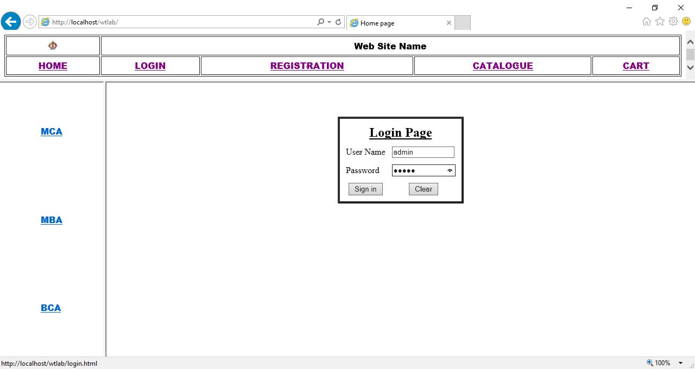

Ch. Vijayananda Ratnam@Dept. Of Computer Science | 47

Web Technologies Lab Manual as per JNTUK-R13
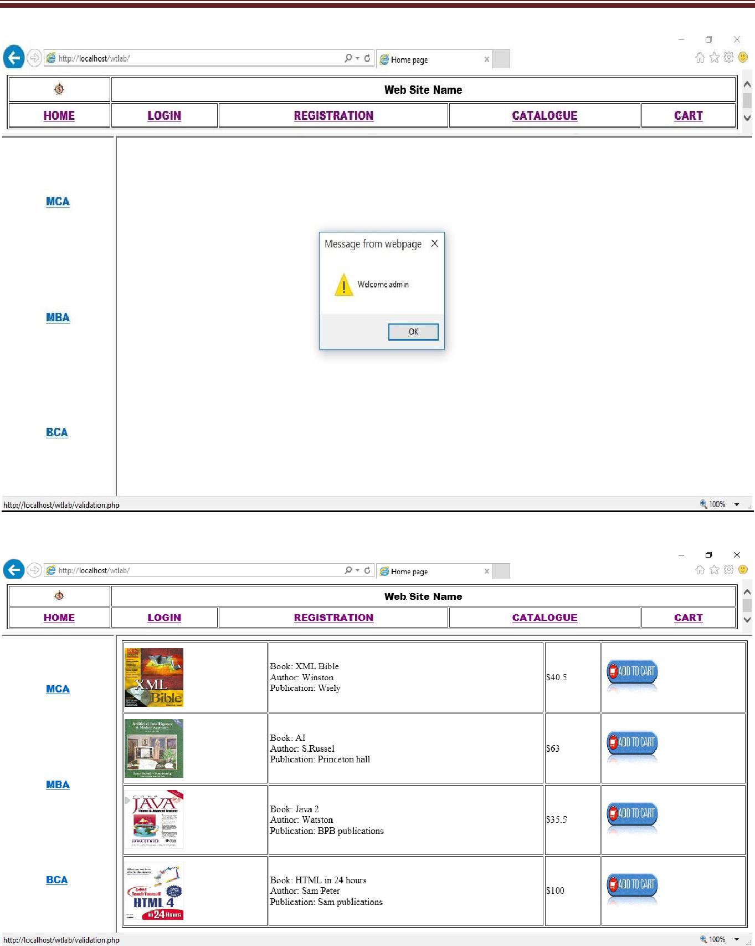

Ch. Vijayananda Ratnam@Dept. Of Computer Science | 48

Web Technologies Lab Manual as per JNTUK-R13

22. Install a database (MySQL or Oracle).

Create a table which should contain at least the following fields: name, password, email-id, phone Number (these should hold the data from the registration form). Write a PHP program to connect to that database and extract data from the tables and display them. Experiment with various SQL queries. Insert the details of the users who register with the web site, whenever a new user clicks the submit button in the registration page.

registration table:

CREATE TABLE registration
(
uname varchar(25) NOT NULL,
pass varchar(25) NOT NULL,

email varchar(25) NOT NULL,
phno bigint(10) NOT NULL,
UNIQUE KEY (uname)
)

registration.html

<html>

<head>
<title> User Registration Page</title>
<script language="javascript">
function validate()

{
var nam = document.f1.uname.value;
if(nam=="")
{

alert("Please enter name");
document.f1.uname.focus;
return false;
}

var pwd = document.f1.pass.value;
if(pwd=="")
{
alert("Please enter Password");
document.f1.pass.focus;

return false;
}
var email = document.f1.email.value;
if(email=="")

{
alert("Please enter youe email");
document.f1.email.focus;
return false;

}
var phno = document.f1.phone.value;
len=phno.length
if(phno=="" || len != 10)

{
alert("Please enter phno or should be strictly 10 digits");
document.f1.phone.focus;
return false;

}
}
</script>
</head>

<body>
<br/><br/><br/>
<center>
<form name="f1" action="insertData.php" method="post" onsubmit="javascript:return

validate()">
<table border="3" cellpadding="0" cellspacing="0">
<tr>
<td>

<table cellspacing="10">
<tr>
<td colspan="2" align="center"><h2><u>User Registration Form</u></h2></td>
</tr>

Ch. Vijayananda Ratnam@Dept. Of Computer Science | 49

Web Technologies Lab Manual as per JNTUK-R13

<tr>

<td> User Name</td>
<td><input type="text" name="uname" size="50"></td>
</tr>
<tr>

<td> Password</td>

<td><input type="password" name="pass" size="50"></td> </tr>

<tr>

<td> E-mail</td>
<td><input type="text" name="email" size="50"></td>
</tr>
<tr>

<td> Phone</td>
<td><input type="text" name="phone" size="15"></td>
</tr>
<tr>

<td colspan="2" align="center"><input type="submit" value="submit"></td>
</tr>
</table>
</td>

</tr>
</table>
</form>
</center>

</body>
</html>

insertData.php

<?php
$conn = mysql_connect("localhost","root","");

if($conn)
echo "Connected to database!!!";
else
echo "Failed to Connect:".mysql_error();
mysql_select_db("test",$conn) or die("No Database existing:".mysql_error());

if(isset($_REQUEST['uname']))
{
$uname=$_REQUEST['uname'];
$pass=$_REQUEST['pass'];

$email=$_REQUEST['email'];
$phno=(float)$_REQUEST['phone'];

$query = "INSERT INTO registration VALUES('$uname','$pass','$email','$phno')"; mysql_query($query);

$result = mysql_query("select * from registration");
?>
<html>
<body>

<br/><br/><br/>

<p align="right"><a href="registration.html">[Registration Page]</a></p> <center>

<font face="verdana" size="4">

<table border="1" cellpadding="0" cellspacing="0">
<tr>
<th colspan="4" align="center">User List</td>
</tr>

<tr>
<th> S.No.</th>
<th> User Name</th>
<th> Email</th>

<th>Phone</th>
</tr>
<?php $num=1; while($row = mysql_fetch_array($result))

{ ?> <tr>

<td><?php echo $num++; ?> </td> <td><?php echo $row['uname']; ?> </td> <td><?php echo $row['email']; ?> </td>

Ch. Vijayananda Ratnam@Dept. Of Computer Science | 50

Web Technologies Lab Manual as per JNTUK-R13

<td><?php echo $row['phno']; ?> </td>

</tr>
<?php }?>
</table>
</center>

</body>
</html>
<?php } ?>

OUTPUT:
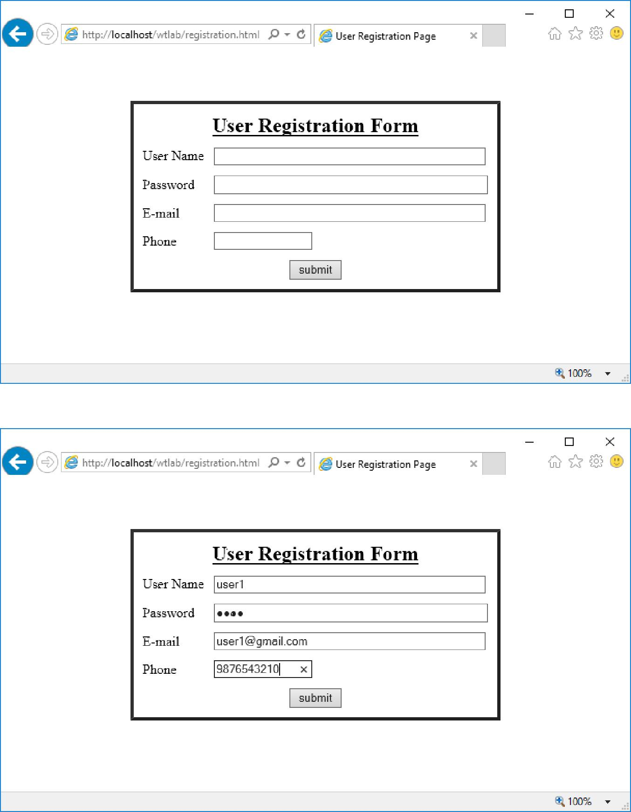

Ch. Vijayananda Ratnam@Dept. Of Computer Science | 51

Web Technologies Lab Manual as per JNTUK-R13
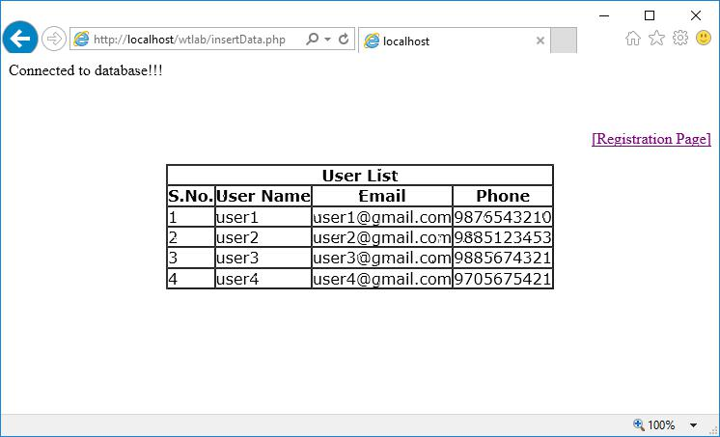

Ch. Vijayananda Ratnam@Dept. Of Computer Science | 52

Web Technologies Lab Manual as per JNTUK-R13

- Write a PHP which does the following job: Insert the details of the 3 or 4 users who register with the web site by using registration form. Authenticate the user when he/she submits the login form using the user name and password from the database..

login.html

<html>
<head>
<title> Sign-in Page </title>

<script language="javascript">
function validate()
{
var nam = document.f1.uname.value;

if(nam=="")
{
alert("Please enter name");
document.f1.uname.focus;

return false;
}
var pwd = document.f1.pass.value;
if(pwd=="")

{
alert("Please enter Password");
document.f1.pass.focus;
return false;

}
}
</script>
</head>

<body>
<br/><br/><br/>
<center>
<form name="f1" action="validation.php" method="post" onsubmit="javascript:return

validate()">
<table border="3" cellpadding="0" cellspacing="0">
<tr>
<td>
<table cellspacing="10">

<tr>
<td colspan="2" align="center"><h2><u>Login Page<u></h2></td>
</tr>
<tr>

<td> User Name</td>
<td><input type="text" name="uname" size="15"></td>
</tr>
<tr>

<td> Password</td>

<td><input type="password" name="pass" size="15"></td> </tr>
<tr>

<td colspan="2" align="center"><input type="submit" value="submit"></td>

</tr>
</table>

</td>
</tr>
</table>
</form>

</center>
</body>
</html>

Ch. Vijayananda Ratnam@Dept. Of Computer Science | 53

Web Technologies Lab Manual as per JNTUK-R13

validation.php

<?php
$conn = mysql_connect("localhost","root","");
if($conn)

echo "<h4>Connected to Database.....!!";
else
echo "Failed to Connect:".mysql_error()."</h4>";
mysql_select_db("test",$conn) or die("No Database existing:".mysql_error());

if(isset($_POST['uname']))
{
$uname=$_POST['uname'];
$pass=$_POST['pass'];

echo"<br/><br/><br/><p align='right'><a href='login.html'>[Login Page]</a></p>";
$res = mysql_query("select * from registration where uname='$uname' and pass ='$pass'");
$count=mysql_num_rows($res);
if($count)

echo "<br/><br/><br/><h2 align='center'>Welcome $uname!!!!</h2>";
else
echo "<br/><br/><br/><h2 align='center'>Invalid Username/Password/Try
again!!!!!</h2>";

}
?>

OUTPUT:
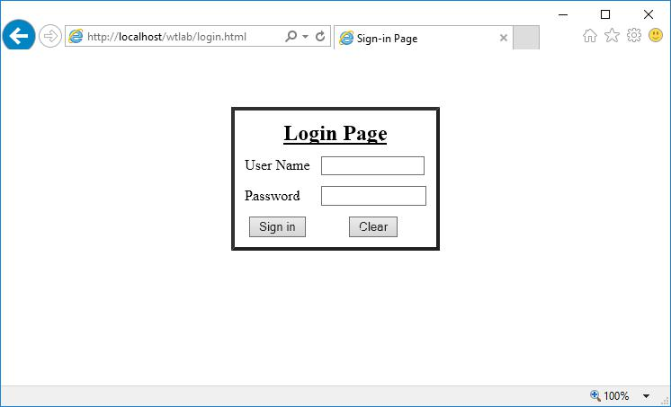

Ch. Vijayananda Ratnam@Dept. Of Computer Science | 54

Web Technologies Lab Manual as per JNTUK-R13
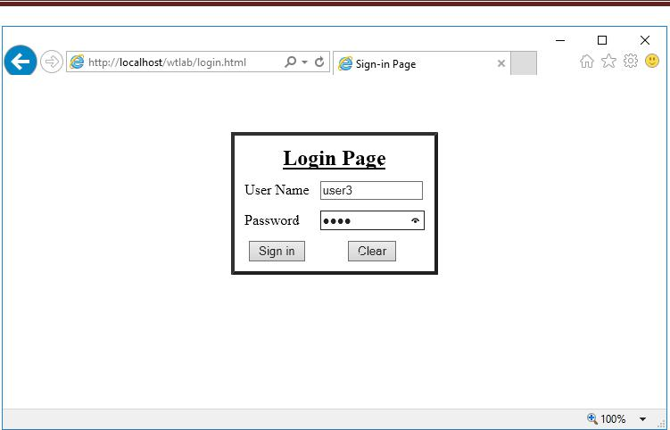
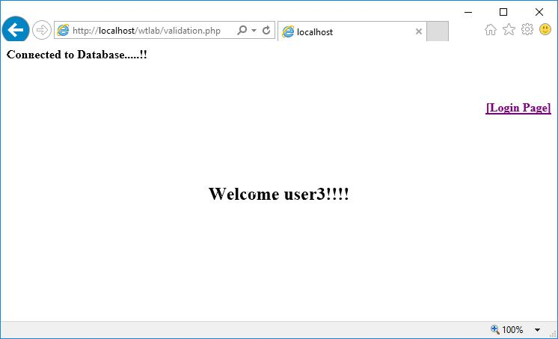

Ch. Vijayananda Ratnam@Dept. Of Computer Science | 55

Web Technologies Lab Manual as per JNTUK-R13
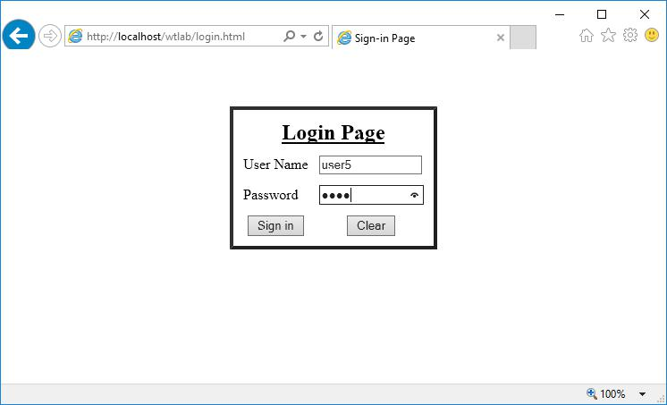
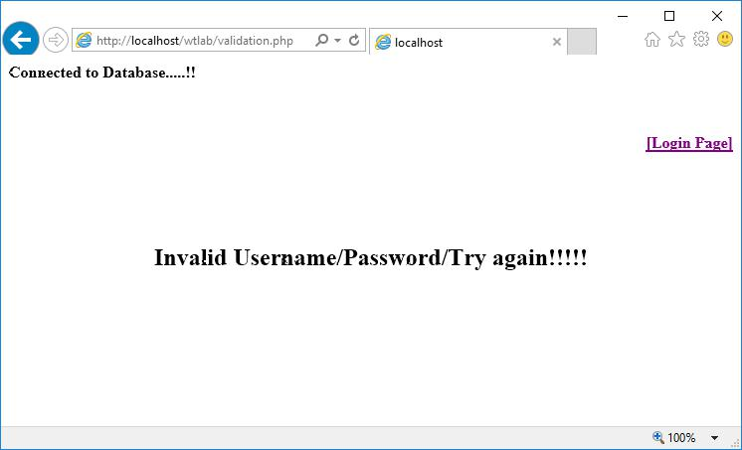

Ch. Vijayananda Ratnam@Dept. Of Computer Science | 56

Web Technologies Lab Manual as per JNTUK-R13

- Create tables in the database which contain the details of items (books in our case like Book name, Price, Quantity, Amount) of each category. Modify your catalogue page (week 2)in such a way that you should connect to the database and extract data from the tables and display them in the catalogue page using PHP

Catalogue table

CREATE TABLE catalogue
(

bname varchar(50) NOT NULL,
auth varchar(25) NOT NULL,
publ varchar(25) NOT NULL,
isbn varchar(20) NOT NULL,

edi varchar(10) NOT NULL,
cost int(5) NOT NULL,
qty int(3) NOT NULL,
UNIQUE KEY(bname)

)

bkEntryForm.html

<html>
<head>
<title> Catalogue Page</title>

<script language="javascript">
function validate()
{
var nam = document.f1.bname.value;

if(nam=="")
{
alert("Please enter Book name");
document.f1.bname.focus();

return false;
}
var auth = document.f1.auth.value;
if(auth=="")
{

alert("Please enter Author Name");
document.f1.auth.focus();
return false;
}

var publ = document.f1.publ.value;
if(publ=="")
{
alert("Please enter Publisher name");

document.f1.publ.focus();
return false;
}
var isbn = document.f1.isbn.value;

if(isbn=="")
{
alert("Please enter ISBN Number");
document.f1.isbn.focus();

return false;
}
var ed = document.f1.edi.value;
if(ed=="")

{
alert("Please enter book edition");
document.f1.edi.focus();
return false;

}
var cost = document.f1.cost.value;
if(cost=="")
{

alert("Please enter cost of the book");
document.f1.cost.focus();
return false;
}

Ch. Vijayananda Ratnam@Dept. Of Computer Science | 57

Web Technologies Lab Manual as per JNTUK-R13

var qty = document.f1.qty.value;

if(qty=="")
{
alert("Please enter number of books you want!!!");
document.f1.qty.focus();

return false;
}
}
</script>

</head>
<body>
<br/><br/><br/>
<center>

<form name="f1" action="Catalogue.php" method="post" onsubmit="javascript:return
validate()">
<table border="3" cellpadding="0" cellspacing="0">
<tr>

<td>
<table cellspacing="5">
<tr>
<td colspan="2" align="center"><h2><u>Book Details Entry Form</u></h2></td>

</tr>
<tr>
<td> Book Name</td>
<td><input type="text" name="bname" size="50"></td>

</tr>
<tr>
<td> Author</td>
<td><input type="text" name="auth" size="50"></td>

</tr>
<tr>
<td> Publication</td>
<td><input type="text" name="publ" size="50"></td>

</tr>
<tr>
<td> ISBN</td>
<td><input type="text" name="isbn" size="15"></td>
</tr>

<tr>
<td> Edition</td>
<td><input type="text" name="edi" size="15"></td>
</tr>

<tr>
<td> Cost</td>
<td>$<input type="text" name="cost" size="5"></td>
</tr>

<tr>
<td> Quantity</td>
<td><input type="text" name="qty" size="3"></td>
</tr>

<tr>
<td colspan="2" align="center"><input type="submit" value="submit"></td>
</tr>
</table>

</td>
</tr>
</table>
</form>

</center>
</body>
</html>

Ch. Vijayananda Ratnam@Dept. Of Computer Science | 58

Web Technologies Lab Manual as per JNTUK-R13

Catalogue.php

<?php
$conn = mysql_connect("localhost","root","");
if($conn)

echo "Connected to database!!!";
else
echo "Failed to Connect:".mysql_error();
mysql_select_db("test",$conn) or die("No Database existing:".mysql_error());

if(isset($_POST['bname']))
{
$bname=$_POST['bname'];

$auth=$_POST['auth'];
$publ=$_POST['publ'];
$isbn=$_POST['isbn'];
$edi=$_POST['edi'];

$cost=(float)$_POST['cost'];
$qty=(int)$_POST['qty'];

echo"<br/><br/><br/><p align='right'><a href='bkEntryForm.html'>[Book Entry Page]</a></p>"; $query = "INSERT INTO catalogue VALUES('$bname','$auth','$publ','$isbn','$edi','$cost','$qty')";
mysql_query($query);
$result = mysql_query("select * from catalogue");
?>
<html>

<body><center>
<font face="verdana" size="4">
<table border="1" cellpadding="0" cellspacing="0">
<tr>

<th colspan="8" align="center">Books List</td>
</tr>
<tr>
<th>S.No.</th>

<th>Title</th>
<th>Author</th>
<th> Publication</th>
<th>ISBN</th>
<th>Edition</th>

<th>Cost</th>
<th>Quantity</th>
</tr>
<?php $num=1; while($row = mysql_fetch_array($result))

{ ?> <tr>
<td align="center"><?php echo $num++; ?> </td> <td align="left"><?php echo $row['bname']; ?> </td> <td align="left"><?php echo $row['auth']; ?> </td> <td align="left"><?php echo $row['publ']; ?> </td> <td align="center"><?php echo $row['isbn']; ?> </td> <td align="center"><?php echo $row['edi']; ?> </td> <td align="center"><?php echo $row['cost']; ?> </td> <td align="center"><?php echo $row['qty']; ?> </td>

</tr> <?php }?> </table> </center>
</body>
</html>

<?php } ?>

Ch. Vijayananda Ratnam@Dept. Of Computer Science | 59

Web Technologies Lab Manual as per JNTUK-R13

OUTPUT:
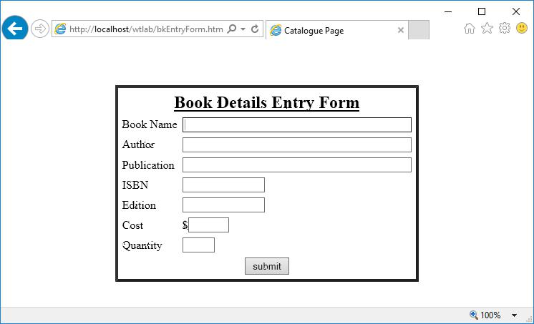
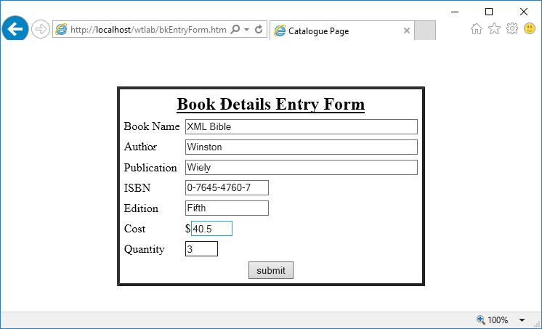

Ch. Vijayananda Ratnam@Dept. Of Computer Science | 60

Web Technologies Lab Manual as per JNTUK-R13
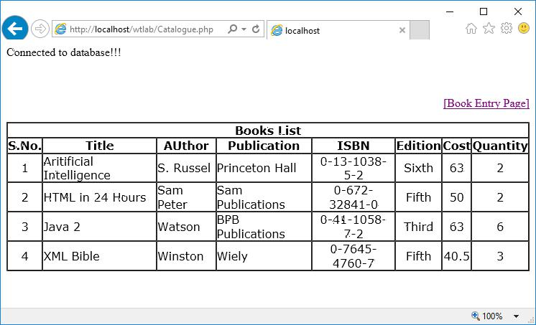

Ch. Vijayananda Ratnam@Dept. Of Computer Science | 61

Web Technologies Lab Manual as per JNTUK-R13

25. HTTP is a stateless protocol. Session is required to maintain the state.

The user may add some items to cart from the catalog page. He can check the cart page for the selected items. He may visit the catalogue again and select some more items. Here our interest is the selected items should be added to the old cart rather than a new cart. Multiple users can do the same thing at a time (i.e., from different systems in the LAN using the ip-address instead of local host). This can be achieved through the use of sessions. Every user will have his own session which will be created after his successful login to the website. When the user logs out his session should get invalidated (by using the method session. invalidate () ).

Modify your catalogue and cart PHP pages to achieve the above mentioned functionality using sessions.

style.css

body
{

width:800px;
}
.txt-heading
{

padding: 5px 10px;
font-size:1.1em;
font-weight:bold;
color:#999;
}

.btnRemoveAction
{
color:#D60202;
border:0;

padding:2px 10px;
font-size:0.9em;
}
#btnEmpty

{
background-color:#D60202;
border:0;
padding:1px 10px;

color:#FFF;
font-size:0.8em;
font-weight:normal;
float:right;

text-decoration:none;
}
.btnAddAction
{

background-color:#79b946;
border:0;
padding:3px 10px;
color:#FFF;

margin-left:1px;
}
#shopping-cart
{

border-top: #79b946 2px solid;
margin-bottom:30px;
}
#shopping-cart .txt-heading
{

background-color: #D3F5B8;
}
#shopping-cart table
{

width:100%;
background-color:#F0F0F0;
}
#shopping-cart table td

Ch. Vijayananda Ratnam@Dept. Of Computer Science | 62

Web Technologies Lab Manual as per JNTUK-R13

{

background-color:#FFFFFF;
}
.cart-item
{

border-bottom: #79b946 1px dotted;
padding: 10px;
}
#product-grid

{
border-top: #F08426 2px solid;
margin-bottom:30px;
}

#product-grid .txt-heading
{
background-color: #FFD0A6;
}

.product-item {
float:left;
background:#F0F0F0;
margin:15px;

padding:5px;
}
.product-item div
{

text-align:center;
margin:10px;
}
.product-price

{
color:#F08426;
}
.product-image {

height:100px;
background-color:#FFF;
}

dbController.php

<?php
class DBController {
private $host = "localhost";
private $user = "root";

private $password = "";
private $database = "test";

function __construct() {

$conn = $this->connectDB();
if(!empty($conn)) {
$this->selectDB($conn);
}

}

function connectDB() {

$conn = mysql_connect($this->host,$this->user,$this->password); return $conn;
}

function selectDB($conn) {

mysql_select_db($this->database,$conn);
}

function runQuery($query) {

$result = mysql_query($query);
while($row=mysql_fetch_assoc($result)) {
$resultset[] = $row;
}

if(!empty($resultset))
return $resultset;
}

Ch. Vijayananda Ratnam@Dept. Of Computer Science | 63

Web Technologies Lab Manual as per JNTUK-R13

index.php

<?php
session_start();
require_once("dbcontroller.php");

$db_handle = new DBController();
if(!empty($_GET["action"])) {
switch($_GET["action"]) {
case "add":

if(!empty($_POST["quantity"])) {

$productByCode = $db_handle->runQuery("SELECT * FROM tblproduct WHERE code='" . $_GET["code"] . "'");

$itemArray =

array($productByCode[0]["code"]=>array('name'=>$productByCode[0]["name"],
'code'=>$productByCode[0]["code"], 'quantity'=>$_POST["quantity"], 'price'=>$productByCode[0]["price"]));

if(!empty($_SESSION["cart_item"])) {

if(in_array($productByCode[0]["code"],$_SESSION["cart_item"])) {
foreach($_SESSION["cart_item"] as $k => $v) {
if($productByCode[0]["code"] == $k)
$_SESSION["cart_item"][$k]["quantity"]

= $_POST["quantity"];
}
} else {
$_SESSION["cart_item"] =

array_merge($_SESSION["cart_item"],$itemArray);
}
} else {
$_SESSION["cart_item"] = $itemArray;

}
}
break;
case "remove":

if(!empty($_SESSION["cart_item"])) {
foreach($_SESSION["cart_item"] as $k => $v) {
if($_GET["code"] == $k)
unset($_SESSION["cart_item"][$k]);

if(empty($_SESSION["cart_item"]))
unset($_SESSION["cart_item"]);
}
}

break;
case "empty":
unset($_SESSION["cart_item"]);
break;

}
}
?>
<HTML>

<HEAD>
<TITLE>Simple PHP Shopping Cart</TITLE>
<link href="style.css" type="text/css" rel="stylesheet" />
</HEAD>

<BODY>
<div id="shopping-cart">

<div class="txt-heading">Shopping Cart <a id="btnEmpty" href="index.php?action=empty">Empty Cart</a></div> <?php

if(isset($_SESSION["cart_item"])){
$item_total = 0;
?>
<table cellpadding="10" cellspacing="1">

<tbody>
<tr>
<th><strong>Name</strong></th>
<th><strong>Code</strong></th>

<th><strong>Quantity</strong></th>
<th><strong>Price</strong></th>
<th><strong>Action</strong></th>
</tr>

Ch. Vijayananda Ratnam@Dept. Of Computer Science | 64

Web Technologies Lab Manual as per JNTUK-R13

<?php

foreach ($_SESSION["cart_item"] as $item){
?>
<tr>

<td><strong><?php echo $item["name"]; ?></strong></td> <td><?php echo $item["code"]; ?></td>
<td align=center><?php echo $item["quantity"]; ?></td>
<td align=right><?php echo "$".$item["price"]; ?></td>

<td><a href="index.php?action=remove&code=<?php echo $item["code"]; ?>" class="btnRemoveAction">Remove Item</a></td>
</tr>
<?php
$item_total += ($item["price"]*$item["quantity"]);

}
?>

<tr>

<td colspan="5" align=right><strong>Total:</strong> <?php echo "$".$item_total; ?></td>
</tr>
</tbody>
</table>

<?php
}
?>
</div>

<div id="product-grid">
<div class="txt-heading">Products</div>
<?php

$product_array = $db_handle->runQuery("SELECT * FROM tblproduct ORDER BY id ASC"); if (!empty($product_array)) {

foreach($product_array as $key=>$value){
?>

<div class="product-item">

<form method="post" action="index.php?action=add&code=<?php echo $product_array[$key]["code"]; ?>">

<div class="product-image"><img src="<?php echo $product_array[$key]["image"]; ?>" height="100" width="75"></div>

<div><strong><?php echo $product_array[$key]["name"]; ?></strong></div>

<div class="product-price"><?php echo "$".$product_array[$key]["price"]; ?></div> <div><input type="text" name="quantity" value="1" size="2" /><input type="submit"
value="Add to cart" class="btnAddAction" /></div>

</form>
</div>
<?php
}

}
?>
</div>
</BODY>

</HTML>

Ch. Vijayananda Ratnam@Dept. Of Computer Science | 65

Web Technologies Lab Manual as per JNTUK-R13

OUTPUT

Empty Cart
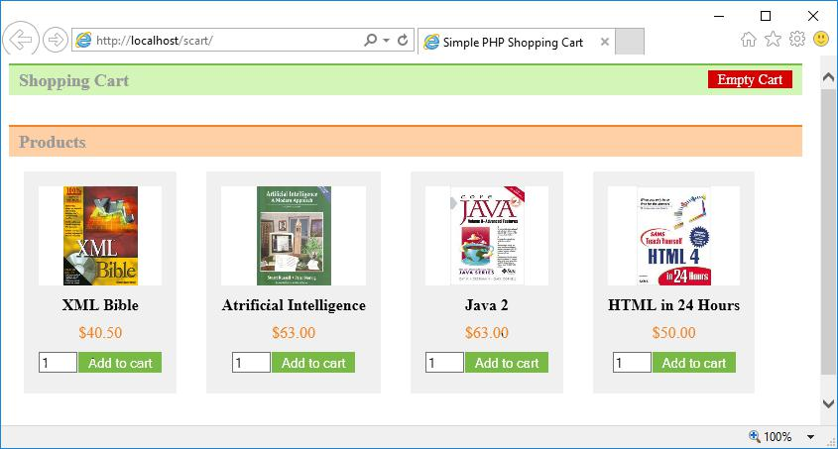

After adding items to cart
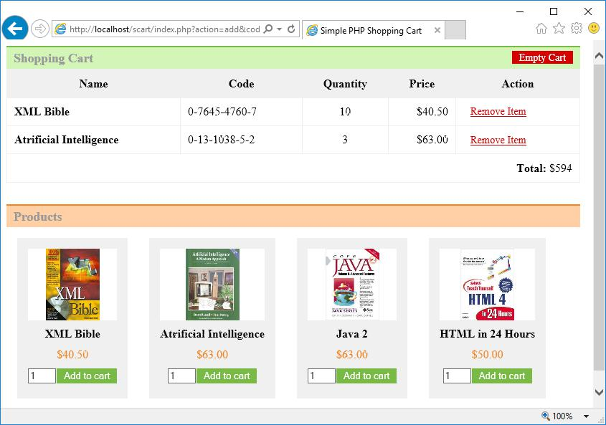

Ch. Vijayananda Ratnam@Dept. Of Computer Science | 66

Web Technologies Lab Manual as per JNTUK-R13

After modification
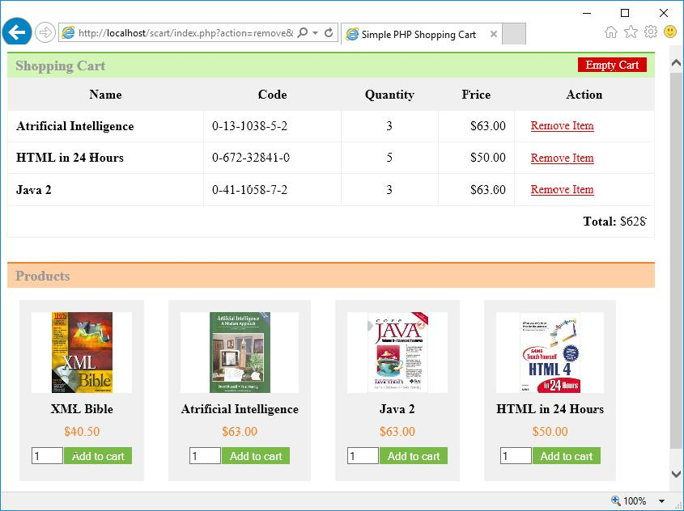

Ch. Vijayananda Ratnam@Dept. Of Computer Science | 67

